MINISTRY OF DEFENCE & MILITARY VETERANS

NATIONAL ASSEMBLY
QUESTION FOR WRITTEN REPLY

2985. Mr S J F Marais (DA) to ask the Minister of Defence and Military Veterans:
(1) (a) What was the basis of the 23,1 % increase in the salaries of employees of the Armaments Corporation of South Africa (Armscor) in the 2017-18 financial year, (b) how were the specified salary increases justified against a lower budget and (c) why are there no correlations between internal targets of employees and the core function activities of Armscor;
(2) whether Armscor utilised reserve funds to fund the increase in employee salaries;
(3) what are the relevant details of the (a) salary increases of Armscor employees since 1 April 2018, including a detailed breakdown of (i) salary increases and bonuses for senior management service employees and (ii) any other benefits for employees such as free hunting trips and the Cape Town Jazz Festival, (b) basis for the increases and (c) source fund(s) from which the increases will be funded? NW3299E

RESPONSE

- (a) The basis of the increase can be summarised as follows:

- The redress of unjustifiable wage gaps between people doing the same job or work that is similar. This parity project was initiated as a result of the new Labour Law amendments on equal pay for same or similar work or work of equal value. In so doing Armscor followed the prescribed Gazetted Regulations.

- It is also attributable to the internal promotions across the organisation in line with the corporate Promotion Practice.

- There was also the filling of vacancies that were vacant in the previous financial year.

- During the last six financial years the Discovery medical premiums increased at an average of 9.1% per annum.

- There was insourcing of contractors from across the organisation.

- The annual increases of 7.5% contributed to the total amount.

- Lastly Voluntary Severance Packages for about 30 employees were paid to those who opted to leave the organisation

- (b) Salary increases were justified in the sense that Armscor needed to comply with legislation as well as ensuring that the organisation remains competitive and is able to attract and retain the highly sought after skills that are necessary in ensuring that it delivers work of superior quality.

These increases were projected and budgeted for. Armscor has also adopted a strict policy in filling vacancies that are critical to the operations of the organisation by optimising the utilisation of these resources hence deriving huge operational savings as depicted in the pie chart below. These savings amounted to R22,4m in total.

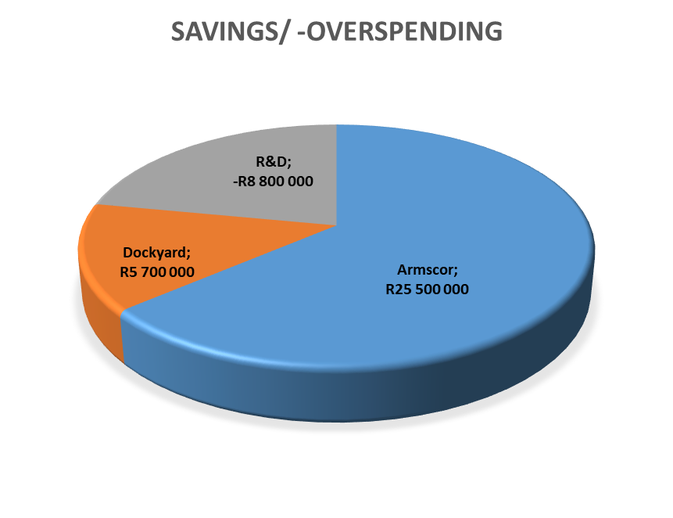

- (c) Armscor is of the view that there is a correlation between the internal targets and core functions of the organisation. For example, acquisition targets relating to the turnaround times for placing orders formed part of the corporate score card.

QUESTION 2

(2) Whether Armscor utilised reserve funds to fund the increase in employee salaries;

RESPONSE

Armscor did not utilise reserves to fund salary increases; as stated these were projected and absorbed in the cost savings with the exception of voluntary severance packages which were provided for in the reserves.

QUESTION 3
(3) what are the relevant details of the (a) salary increases of Armscor employees since 1 April 2018, including a detailed breakdown of (i) salary increases and bonuses for senior management service employees and (ii) any other benefits for employees such as free hunting trips and the Cape Town Jazz Festival, (b) basis for the increases and (c) source fund(s) from which the increases will be funded? NW3299E

3 (a)

SUMMARY OF SALARY INCREASES
Category | 2017/18 | 2018/19
Executives | 7.5 | 6.2
Snr Management | 7.5 | 6.5
Middle Management | 7.5 | 7.75
Professionals | 7.5 | 7.75
Skilled Workers | 7.5 | 7.75
General Workers | 7.5 | 7.75

SALARY BREAKDOWN

DIRECT PERSONNEL COSTS PER FINANCIAL YEAR 2017/18 TO 2018/19
Financial Year | 2017/18 | 2018/19
Top Management  (EXCO Members) incl. CEO | 16 637 652.88 | 17 667 041.01
EM/Head of Departments | 24 625 317.08 | 26 067 719.19
Snr Management | 75 873 769.26 | 76 396 300.53
Middle Management | 397 773 481.19 | 420 516 743.11
Specialist | 202 950 419.05 | 229 424 405.86
Semi Skilled | 184 121 076.93 | 186 819 269.59
General Workers | 41 472 291.72 | 45 671 529.3
Total | - 4 008.11 | 1 002 563 008.59

3 (a) (i) Group Executives received bonuses of 10% of annual package and the rest of employees received bonuses of 8% of total annual package which on average amounted to an equivalent of a month’s additional salary.

(ii) There were no additional benefits offered to employees.

- (b) The increases were due to:
- Normal annual salary increments.
- Compliance with legislation.
- Escalation of medical aid costs.
- Compliance with internal policies.
- Financial sustainability initiative as approved by the Board (Voluntary Severance Package).

3 (c) The source of the funds for the salary increases were normal budget provisions.

