FORWRITTENREPLY
QUESTION 2982

NATONALASSEMBLY
36/1/4/1(201800295)

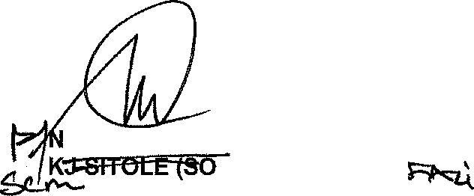
DATE OF PUBLICATION IN INTERNAL QUESTION PAPER:.19 OCTOBER 2018 (INTERNAL QUESTION PAPER NO 33-2018)

2982. Mr J R B Lorimer (DA) to ask the Minister of Police:

What number of (a) cases relating to incidents of suspected corruption were reported in terms of the Prevention and Combating of Corrupt Activities Act, Act 12 of 2004, as amended, to the (i) SA Police Service and (ii) Directorate for Priority Crime Investigation (aa) in each of the past three calendar years and (bb) since 1 January 2018 and (b) the specified cases were (i) investigated and (ii) successfully prosecuted in each case?
NW3296E
REPLY:

(a)(i)(ii)(aa)(bb)(b)(i)(ii)

The information that is required, is not readily available and must be verified before the information can be submitted. A request is hereby made for an extension of three weeks, in order for the South African Police Service to provide the required information.

Reply to question 2982 recommended/not recommended

GENERAL ATIONAL COMMISSIONER: SOUTH AFRICAN POLICE SERVICE
EG) sg'•

Date: zJ›t \1- I s

2

Reply to question 2982 approved/not approved

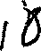
MINISTER OF POLICE BH CELE, MP

Date: \,

