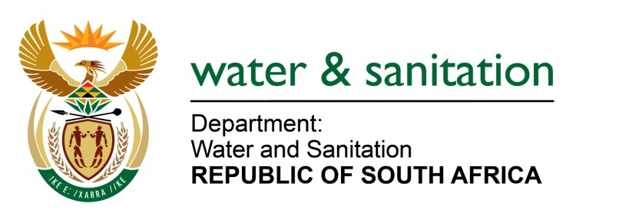

NATIONAL ASSEMBLY

FOR WRITTEN REPLY

QUESTION NO 2975

DATE OF PUBLICATION IN INTERNAL QUESTION PAPER: 9 SEPTEMBER 2022
(INTERNAL QUESTION PAPER NO. 31)

2975. Ms C V King (DA) to ask the Minister of Water and Sanitation:
(1) Whether, in the pursuit to avoid Day Zero in the Nelson Mandela Bay Metropolitan Municipality, the Nelson Mandela Bay University was consulted to do research on alternative water resources to mitigate against the drought; if not, why not; if so, what are the details of the research.
(2) whether any research was conducted by his department on water infrastructure and alternative measures in the Nelson Mandela Bay Metropolitan Municipality to avoid Day Zero; if not, why not; if so, what are the relevant details? NW3611E

---00O00---

MINISTER OF WATER AND SANITATION

- The Nelson Mandela Bay University (NMU) has not been approached to carry out any research on alternative water resources to mitigate against the drought. The NMBM conducted its own research as guided Department of Water and Sanitation Algoa Reconciliation Strategy which was used to develop the NMBM Drought Mitigation Plan (DMP). The NMU is however a stakeholder at the NMBM Joint Operations Centre (JOC) where the DMP is reported which the university can provide their comments and inputs.

- Yes, my Department has conducted the Algoa Reconciliation Strategy since 2011, which aims to reconcile bulk water sources with water requirements over a planning period of at least 25 years to prevent the risk of a water shortages. An annual update of the strategy, called the Status Report, is done which describes the status of the Algoa Water Supply System (WSS) in terms of bulk water infrastructure, water resources, current and future water requirements and yield balance, and recommended interventions and other actions.

One of the key recommendations have been made through the Algoa Reconciliation Strategy was that the NMBM should complete implementation of the Nooitgedacht Coega Low Level Scheme Phase 3 which will provide an additional 70Ml/day potable water to the NMBM. This project will be commissioned at the end of September 2022. Further recommendations of the Reconciliation Strategy were:
- That the Metro should continue with the implementation of re-use schemes to meet the water demands of the Coega Special Economic Zone
- Ensure implementation-readiness for implementation of reuse schemes from the Fish Water Flats WWTW and the planned Coega WWTW; within the constraints of available development funds
- Proceed with planning for a potable reuse scheme, which should be preceded by a pilot scheme; and implementation of the 15Mℓ/d Coega seawater desalination scheme
- Update the comparative costs and potential impacts of raising the Kouga and the Guernakop Dams against investing in a desalination plant as a long-term augmentation option, considering that an EIA application for a 60Ml/d desalination plant has already been granted to CDC by DEA. This should be dependent on the updated yields, once the updated Algoa WSS model is available.
- Evaluate the Lower Sundays River Return Flows scheme at a more detailed reconnaissance level. This should be followed by a Feasibility-level Study by NMBM and considered as one of the next interventions to be considered for implementation. Consideration should be given to treating the water for industrial-quality use; and the municipality should timeously establish whether this scheme is worth pursuing further.
- Implement Water Use Efficiency / Water Conservation Water Demand Management projects to reduce the demand for water
- The Kouga LM should continue with groundwater evaluations and implementation of groundwater schemes, particularly those schemes that can easily integrated into the existing Water Supply System infrastructure. Groundwater initiatives undertaken by Kouga LM will further aim to make the various small towns less reliant on surface water supply. Potential groundwater yields should be updated when additional information becomes available.

---00O00---

