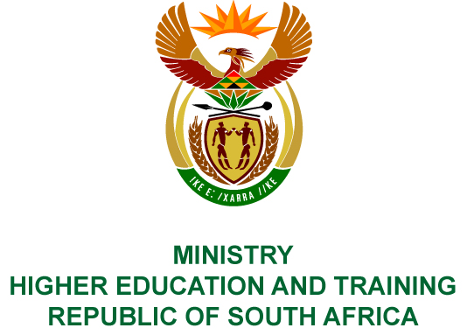
Private Bag X893, Pretoria, 0001, Tel (012) 312 5555, Fax (012) 323 5618
Private Bag X9192, Cape Town, 8000, Tel (021) 469 5150, Fax: (021) 465 7956
Memorandum from the Parliamentary Office
NATIONAL ASSEMBLY
FOR WRITTEN REPLY
QUESTION 2972
DATE OF PUBLICATION OF INTERNAL QUESTION PAPER: 19/10/2018
(INTERNAL QUESTION PAPER NO 33 OF 2018)
Mr A P van der Westhuizen (DA) to ask the Minister of Higher Education and Training:
(1) What number of applications for accreditation of educational programmes were (a) received and (b) finalised by the Council on Higher Education in each of the past three financial years;
(2) what (a) number and (b) percentage of the applications were eventually approved;
(3) what (a) number of applications are currently under consideration by the Council on Higher Education and (b) is the average time from the receipt of the application to the final adjudication on the application for accreditation of educational programmes;
(4) (a) how is the fee per application calculated and (b) what is the (i) total income and (ii) average fee levied per application for accreditation?
NW3286E
REPLY:
The Council on Higher Education (CHE) provided the following response to the questions posed.
- - (2) The table below shows the number of applications received, finalised and accredited:
Financial year | Applications received | Applications finalised | Applications accredited | Percentage of finalised accredited
2015/16 | 483 | 424 | 292 | 68%
2016/17 | 463 | 681 | 549 | 81%
2017/18 | 580 | 784 | 610 | 78%
It should be noted that programmes submitted in one financial year might only receive a Higher Education Quality Committee outcome in the following financial year.
(3) (a) Currently, the CHE has 1 128 new applications for programme accreditation that are in various stages of the process. The sharp increase in submissions is due to higher education institutions, and in particular, the universities of technology, submitting replacement programmes for those that are not aligned to the Higher Education Qualifications Sub–Framework (HEQSF). This alignment process has to be completed by December 2019. From the 1 January 2020, first-year registrations will only be allowed in HEQSF aligned programmes.
- Over the past three years, the average time from receipt of an application to the final decision on accreditation was 8.5 months.
- (a) Public universities do not pay any fees for accreditation applications. Private Higher Education Institutions (PHEIs) are required to make a payment before a programme application can be processed. The calculation of fees is based on a cost recovery basis.
(b) (i) The total income received from accreditation for private institutions in the 2017/18 financial year was R5 476 892. This includes fees for a range of different applications, including programme accreditation and site approval. The different application fees are published on the CHE’s website: http://www.che.ac.za.
(ii) The application fee to PHEIs for the accreditation per programme is currently R12 500.

