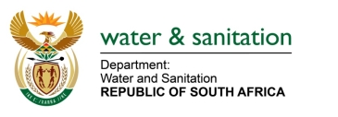

NATIONAL ASSEMBLY

FOR WRITTEN REPLY

QUESTION NO 297

DATE OF PUBLICATION IN INTERNAL QUESTION PAPER: 18 FEBRUARY 2022
(INTERNAL QUESTION PAPER NO. 2)

297. Mrs M R Mohlala (EFF) to ask the Minister of Water and Sanitation:
What steps has his department taken to resolve the water crisis that Polokwane and surrounding areas are facing because of the lack of infrastructure maintenance at the (a) Ebenezer and (b) Olifantspoort bulk water schemes?
---00O00---

MINISTER OF WATER AND SANITATION
The Lepelle Northern Water Board (LNW) is implementing a preventive maintenance plan that is combined with condition-based, predictive, and corrective maintenance on the bulk water infrastructure as a short-term solution to address water supply challenges in Polokwane.
The Department of Water and Sanitation is implementing the Olifantspoort and Ebenezer Water Supply Schemes (O&E WSS) project to upgrade and refurbish the schemes and increase capacity to meet demand in Polokwane and surrounding areas which is projected to grow to 272,3 ML/day by 2043.

Upon completion of the project, it is envisaged that water supply will be improved as follows:
- The capacity of the Olifantspoort scheme which is currently 60 ML/day will be increased by 40 ML/day.
- The capacity of the Ebenezer scheme which is currently 54 ML/day and will be upgraded by 15ML/day to 69 ML/day.

---00O00---

