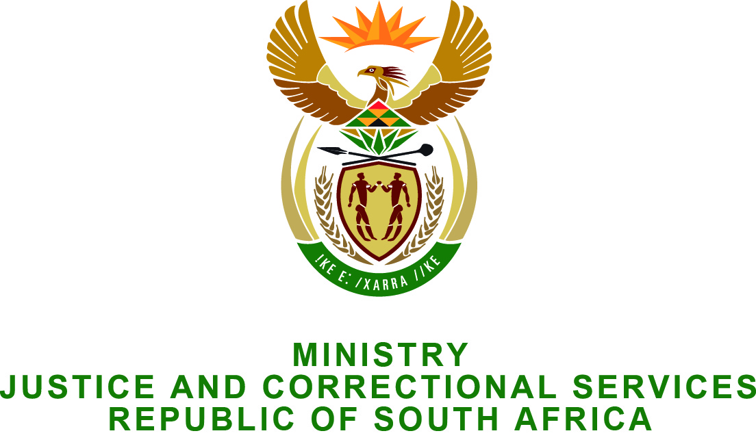

NATIONAL ASSEMBLY
QUESTION FOR WRITTEN REPLY
PARLIAMENTARY QUESTION NO.: 2968
DATE OF QUESTION: 14 AUGUST 2015
DATE OF REPLY: 28 AUGUST 2015

Mr M H Redelinghuys (DA) to ask the Minister of Justice and Correctional Services:
(a) Whether the Law Reform Commission Report on sex work has been finalized; and
(b) on what date is the report envisaged to be published?
NW3472E

REPLY:

- I wish to inform the Honourable Member that the South African Law Reform Commission (SALRC) considered sex work in its investigation into Sexual Offences: Adult Prostitution (Project 107). This investigation has now been finalized, and as required in terms of section 7(1) of the South African Law Reform Commission Act, 1973 (Act No 19 of 1973), the report has been submitted to me during July 2015 for my consideration.
- I am currently still considering the report and the recommendations contained therein. As soon as I finalize considering the report, further announcements will be made.

