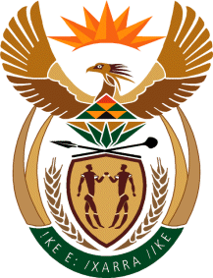

MINISTER IN THE PRESIDENCY: REPUBLIC OF SOUTH AFRICA
Private Bag X1000, Pretoria, 0001, Union Buildings, Government Avenue, PRETORIA
Tel: (012) 300 5200, Website: www.thepresidency.gov.za

NATIONAL ASSEMBLY
WRITTEN QUESTION FOR WRITTEN REPLY

QUESTION NUMBER: 2966
DATE OF PUBLICATIONS: 09 September 2022

2966. Mr H C C Krüger (DA) to ask the Minister in The Presidency:
(1) What number of people have been appointed in the Red Tape Reduction Unit situated in The Presidency, which was announced by the President, Mr M C Ramaphosa, during the State of the Nation Address on 10 February 2022;
(2) what is the (a) total budget allocated to the Red Tape Reduction Unit and (b) budget allocated to the remuneration of people who form part of the specified advisory unit in each year;
(3) whether there are any plans in place to expand the unit; if not, why not; if so, what are the relevant details? NW3599E

DRAFT REPLY

Mr Sipho Nkosi has been seconded from BUSA on a part-time basis to lead the Red Tape Reduction initiative. The Presidency is only responsible for operational costs that may arise . The Red Tape Reduction Team provides coordination and leadership to the work of government to reduce red tape, working with existing government initiatives, in particular those falling under the Department of Small Business Development, and the Department of Trade, Industry and Competition through InvestSA.

Mr Nkosi is supported by current Presidency staff as well as receiving part-time assistance through the Department of Small Business Development.

There is no budget allocated as no new Unit has been set up . The Red Tape Reduction was part of the MTEF document. However, no additional funding has been provided over the MTEFperiod.

Thank You.

