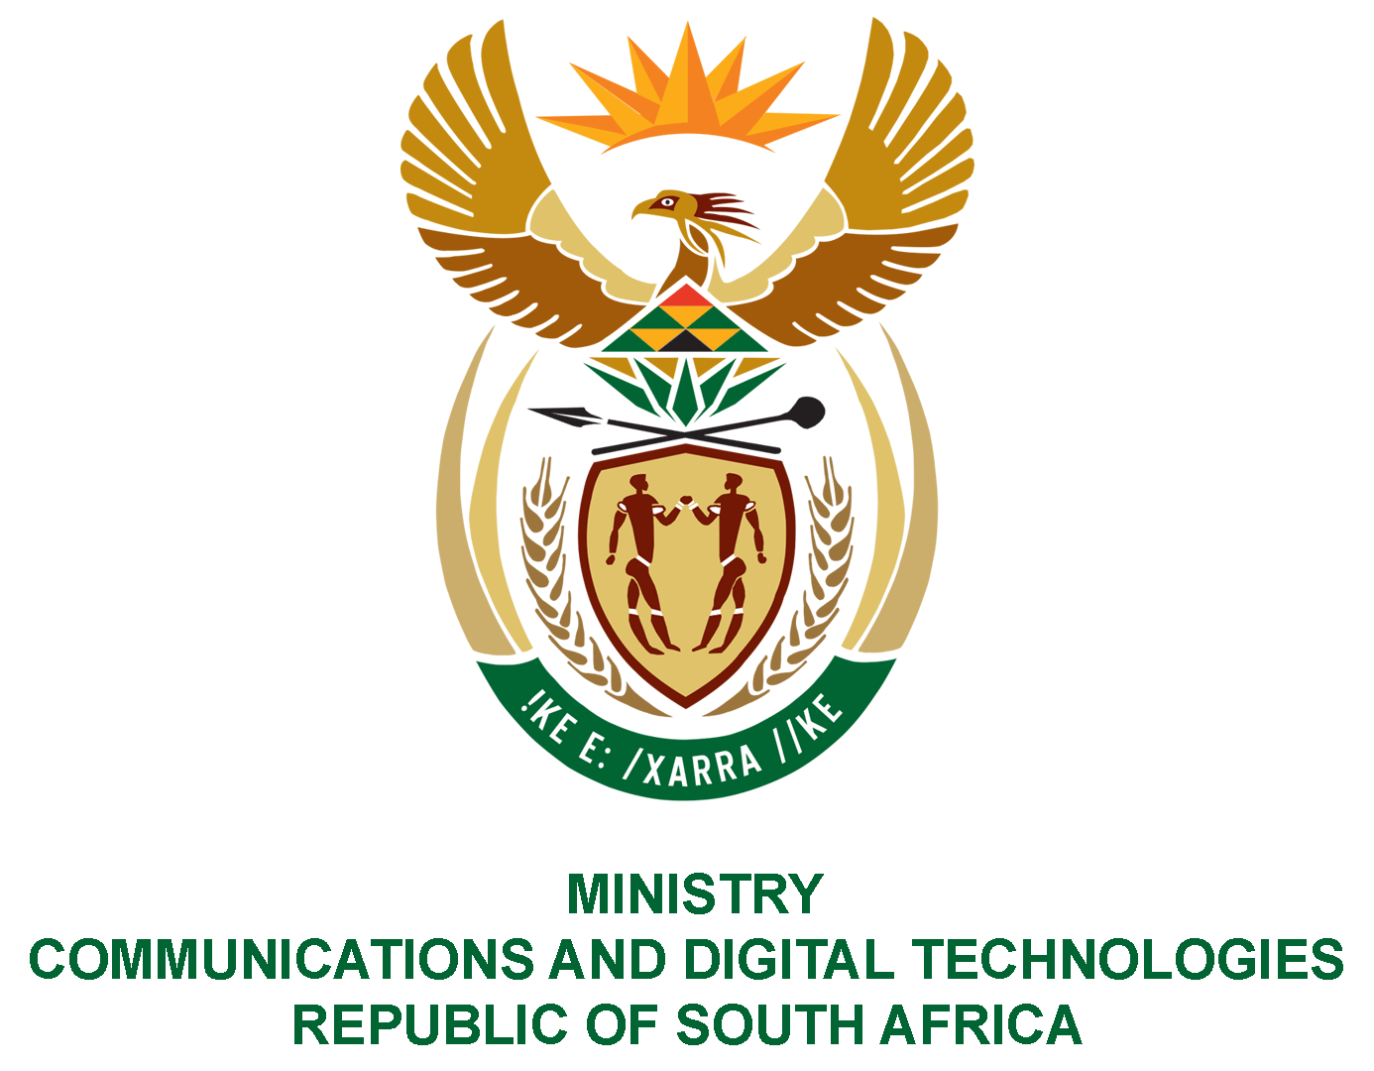
PARLIAMENT OF THE REPUBLIC OF SOUTH AFRICA
NATIONAL ASSEMBLY
WRITTEN REPLY

QUESTION NO: 2962
DATE OF PUBLICATION: 9 SEPTEMBER 2022
QUESTION PAPER NO: 31

Ms T Bodlani (DA) to ask the Minister of Communications and Digital Technologies:

Whether, noting that the SA Post Office is repositioning itself as the Post Office of the future, with no plans to utilise the old red letter deposit boxes that are found across the country and which have become redundant and are in some cases used for ablution and other social ills, particularly by the homeless persons, her department intends to remove the boxes, such as the one located outside 57 Main Street, Townsview, Johannesburg, if not, what is the position in this regard; if so, what are the relevant details?
NW3595E

REPLY:

I have been advised by SAPO as follows:

The programme of removing underutilised red letter deposit boxes is underway. The box at 57 Main Street is scheduled for removal in October 2022.

Authorised for submission by

MR TINYIKO NGOBENI
DIRECTOR-GENERAL (ACTING)
DATE:

Recommended/not recommended

__________________________
HON. PHILLY MAPULANE, MP
DEPUTY MINISTER OF COMMUNICATIONS AND DIGITAL TECHNOLOGIES
DATE:

Approved/ not approved

________________________________
HON. KHUMBUDZO NTSHAVHENI, MP
MINISTER OF COMMUNICATIONS AND DIGITAL TECHNOLOGIES
DATE:

