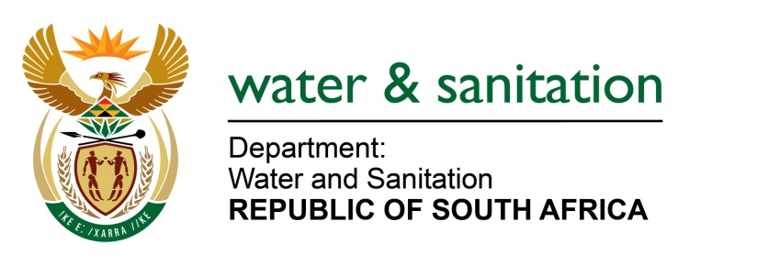

NATIONAL ASSEMBLY

FOR WRITTEN REPLY

QUESTION NO 2956

DATE OF PUBLICATION IN INTERNAL QUESTION PAPER: 9 SEPTEMBER 2022
(INTERNAL QUESTION PAPER NO. 31)

2956. Ms A M M Weber (DA) to ask the Minister of Water and Sanitation:
(1) Whether, with reference to his reply to question 999 on 21 April 2022, the rehabilitation has now started, as it is now six months after the incident; if not, why not; if so, what is the status of the progress that has been made with regard to the rehabilitation.
(2) what are the (a) full relevant details of the rehabilitation plan and (b) timelines for the rehabilitation in the two rivers;
(3) whether he will furnish Ms A M M Weber with the details regarding the progress of the rehabilitation of the two rivers; if not, why not; if so, what are the relevant details;
(4) whether he will furnish Ms A M M Weber with details indicating whether the natural process of rehabilitation has started based on the reports provided to him by the rehabilitation company; if not, what is the position in this regard; if so, what are the relevant details?
NW3589E
---00O00---

MINISTER OF WATER AND SANITATION
- As indicated in response to Question no 2955, an amended rehabilitation plan was submitted on 4 August 2022 to include inputs from the Mpumalanga Tourism and Parks Agency. The approved rehabilitation plan entails deliverables of the project which are categorised into three (3) phases namely:

- Phase 1: Low Flow Eco Status Report
- Phase: 2: Development of Rehabilitation Actions from Phase 1
- Phase 3: Monitoring and Final Report
Implementation of Phase 1 of the rehabilitation plan has commenced, and the Khwezela Mine has appointed qualified team of specialists. The appointment of the team fulfils one of the requirements of the directive issued by this Department. Other key matters that the mine has made progress on include the following:
- Commencement with the first round of monitoring and this has been completed on 19 August 2022 the results have been distributed and the specialist team is working on the results.
- Commencement with the eco status assessment and reconnaissance surveys. The surveys entail systematic screening of the water resources through recording characteristics found in the water resources and recommended actions based on the results obtained.
- Furthermore, a workshop on updating the rehabilitation plan with the specialist panel will be held on 15 September 2022. Specialist workshop on 1st and 2nd round of monitoring will be held October 2022.
(2) The relevant details of the rehabilitation plan are outlined in the Gantt chart attached as Annexure A with an indication of timelines. It is envisaged that implementation of the rehabilitation plan will be completed by 2027.
(3) Provision of the “details regarding the progress of the rehabilitation of the two rivers” can be obtained by submitting a request to the Departmental chief information officer as guided by PAIA.
(4) Provision of the “details indicating whether the natural process of rehabilitation has started based on the reports provided to him by the rehabilitation company” can be obtained by submitting a request to the Departmental Chief Information Officer as guided by PAIA.

---00O00---

