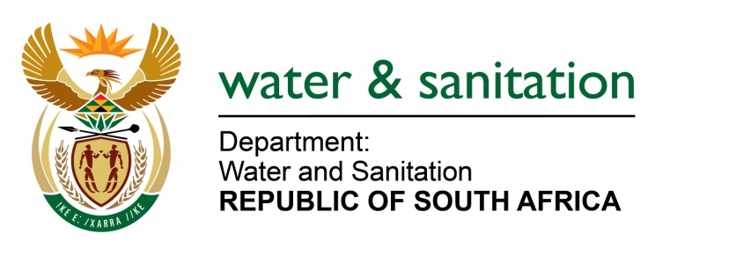

NATIONAL ASSEMBLY

FOR WRITTEN REPLY

QUESTION NO 2955

DATE OF PUBLICATION IN INTERNAL QUESTION PAPER: 9 SEPTEMBER 2022
(INTERNAL QUESTION PAPER NO. 31)

2955. Ms A M M Weber (DA) to ask the Minister of Water and Sanitation:
(1) Whether, with reference to his reply to question 999 on 21 April 2022, in which he indicated that the Kwezela Colliery and his department have agreed that the company will appoint an independent qualified environmental consultant as prescribed in the directive to develop sustainable rehabilitation plan, the independent consultant was appointed as agreed upon with the Kwezela Colliery; if not, why not; if so, who has been appointed to develop the plan;
(2) whether a final rehabilitation plan was submitted on or before 30 April 2022; if not, why not; if so, what are the relevant details.
(3) who was appointed and given the responsibility to execute the rehabilitation plan in the (a) Klein Olifantsriver and (b) Wilge River.
(4) whether the rehabilitation plan was approved by his department; if not, why not; if so, what are the relevant details?
NW3588E

---00O00---

MINISTER OF WATER AND SANITATION

(1) The Biodiversity Company was appointed by Khwezela Colliery to develop and implement a Rehabilitation Plan.
(2) The Rehabilitation plan was submitted before 30 April 2022. However, the plan needed to be reviewed and amended to include the Mpumalanga Tourism and Parks Agency (MTPA) inputs and was subsequently submitted to the department on 04 August 2022.
(3) The Biodiversity Company was appointed by Khwezela Colliery to develop and implement a Rehabilitation Plan for the Klein Olifants and Wilge Rivers.
(4) The Rehabilitation Plan was approved by the department.

---00O00---

