FOR WRITTEN REPLY QUESTION 2954

NATIONAL ASSEMBLY
36/1/4/1(201800287)

DATE OF PUBLICATION IN INTERNAL QUESTION PAPER: 19 OCTOBER 2018 (INTERNAL QUESTION PAPER NO 33-2018)

2954. Mr S P Mhlongo (EFF) to ask the Minister of Police:

(a) What number of police officers were deployed at the meeting held in Xolobeni in the Eastern Cape on 23 September 2018, (b) from which (i) units and (li) police stations were they deployed and (c) what number of police dogs were present?
NW32b6E
REPLY:

(a) A total of 105 members, were deployed. (b)(i)(ii)
(i) Units
Visible Policing
Crime Intelligence
Public Order Policing (POP)
Explosive Unit
Mounted Unit
K9 Unit
Tactical Response Team (TRT)
Video Operators
Provincial Traffic Officers
Local Traffic Officers

s
ii Po ice S ion
Mpisi
Kwandengane
Mzamba
Bizana
Mount Ayliff
Ntabankulu

(c) Two police dogs, with their handlers, were deployed.

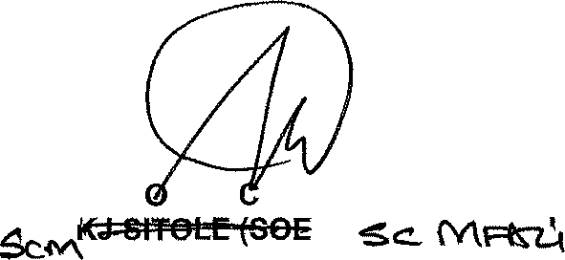
Reply to question 2954 recommended/not recommended

.m, 1 GENERAL
NATI NAL OMMISSIONER: SOUTH AFRICAN POLICE SERVICE

Date: ]g]g -]j- § §

Reply to question 2954 approved/not approved

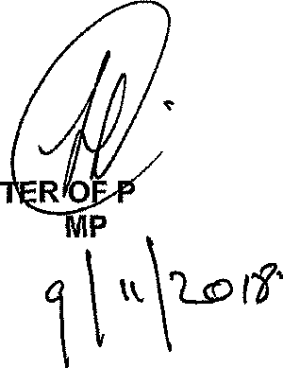
MINIS
BH CELE,

Date: @
OLICE

Due date for submission to the Minister: 26 October 2018

36/1/4/1(201800287)

INFORMATION NOTE

To: The Depu‹y National Commissioner Management Advisory Services

RESPONSE TO QUESTION IN PARLIAMENT: NUMBER 2954

- The response to the above question, is attached.

- The content was perused by the Head: Strategic Management.

MAJOR GENERAL COMPONENT HEAD: STRATEGIC MANAGEMENT L RAB)E

Date:

Informatlon note compiled by: Code & telephone number: Date:
Colonel KB Steyn 012 393 1588

Information note perused and verified by: Brigadier CB Mitchell Gode 8 telephone number: 012 3g3 3381
Date:

