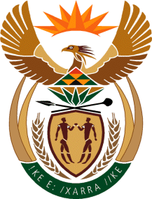

MINISTRY: COMMUNICATIONS
REPUBLIC OF SOUTH AFRICA
Private Bag X 745, Pretoria, 0001, Tel: +27 12 473 0164 Fax: +27 12 473 0585
Tshedimosetso House,1035 Francis Baard Street, Tshedimosetso House, Pretoria, 1000

NATIONAL ASSEMBLY
QUESTION FOR WRITTEN REPLY
QUESTION NUMBER: 2954 of 2015
DATE OF PUBLICATION: 14 AUGUST 2015

MR G R DAVIS (DA) TO ASK THE MINISTER OF COMMUNICATIONS:
With reference to her reply to question 453 on 27 November 2014, (a) when is the envisaged start and end date for the Information for Empowerment Dialogues, (b) which (i) stakeholders and (ii) towns and cities will be visited,(c) how many officials will participate and (d) what is the budgeted costs for the specified dialogues? NW3458E

REPLY: MINISTER OF COMMUNICATIONS
The Minister of Communications received the report from the National Communication Task Team (NCTT). The report is being evaluated. All matters relating to the NCTT will be appropriately responded to once the Minister concludes with the evaluation of the report and expresses her opinion on how the process will be carried forward.

MR NN MUNZHELELE
DIRECTOR GENERAL [ACTING]
DEPARTMENT OF COMMUNICATIONS
DATE:

MS AF MUTHAMBI (MP)
MINISTER OF COMMUNICATIONS
DATE:

