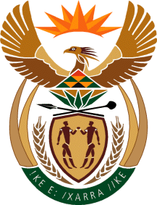

MINISTRY: COMMUNICATIONS
REPUBLIC OF SOUTH AFRICA
Private Bag X 745, Pretoria, 0001, Tel: +27 12 473 0164 Fax: +27 12 473 0585
Tshedimosetso House,1035 Francis Baard Street, Tshedimosetso House, Pretoria, 1000

NATIONAL ASSEMBLY
QUESTION FOR WRITTEN REPLY
QUESTION NUMBER: 2952 of 2015
DATE OF PUBLICATION: 14 AUGUST 2015
Mr G R Davis (DA) to ask the Minister of Communications:

Whether, with reference to her reply to question 2037 on 22 December 2014, the SA Broadcasting Corporation has completed the review of its editorial policies; if not, (a) why not and (b) when is the review expected to be completed; if so, (i) on what date was the review completed, (ii) was there a public participation process, (iii) who was involved in the process and (iv) what were the outcomes of this process?

REPLY: MINISTER OF COMMUNICATIONS
- The SABC is in the process of concluding its editorial policy review, public reviews and participation were undertaken in the 2014/2015 financial year.
- Review completion date is 31 December 2015
- N/A
- Yes across all provinces
- SABC audiences and stakeholders
- All feedback is currently being integrated into the policy

MR NN MUNZHELELE
DIRECTOR GENERAL [ACTING]
DEPARTMENT OF COMMUNICATIONS
DATE:

MS AF MUTHAMBI (MP)
MINISTER OF COMMUNICATIONS
DATE:

