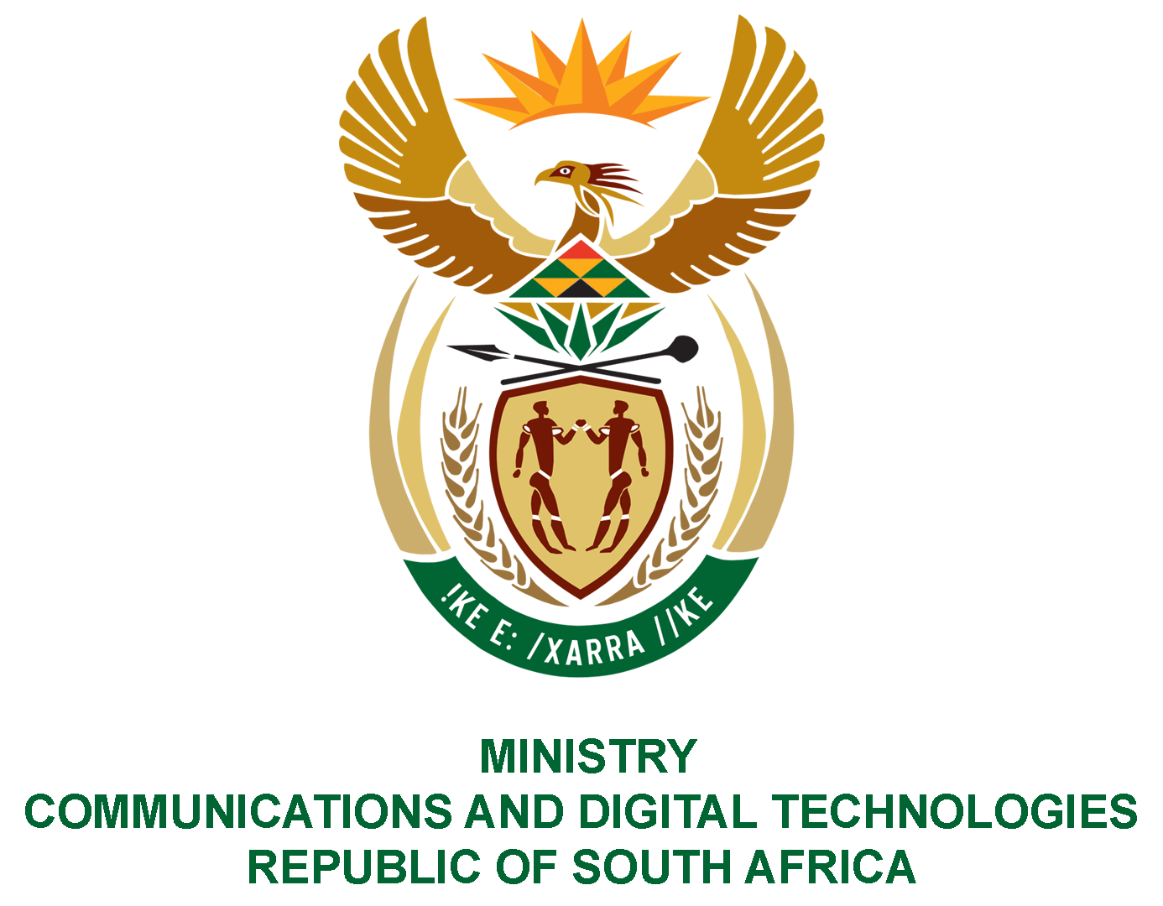
PARLIAMENT OF THE REPUBLIC OF SOUTH AFRICA

NATIONAL ASSEMBLY

WRITTEN REPLY

QUESTION NO: 2941
DATE OF PUBLICATION: 27 November 2020
QUESTION PAPER NO: 50

Ms BS Masango (DA) to ask the Minister of Communications:
What was the total number of branches of the SA Post Office in each year from 2015 to 2020 (a) nationally and (b) in each province? NW3766E
REPLY:

I have been advised by the South African Post Office (SAPO) as follows:

- and (b)

Provinces | 2015 | 2016 | 2017 | 2018 | 2019 | CURRENT  (from April 2020)
Eastern Cape | 354 | 342 | 326 | 323 | 319 | 311
Free State | 158 | 153 | 140 | 140 | 139 | 136
Gauteng | 364 | 354 | 350 | 343 | 328 | 309
KwaZulu-Natal | 329 | 320 | 310 | 310 | 307 | 277
Limpopo | 326 | 324 | 260 | 259 | 259 | 255
Mpumalanga | 192 | 194 | 206 | 207 | 207 | 205
Northern Cape | 142 | 134 | 130 | 130 | 130 | 130
North West | 262 | 247 | 209 | 209 | 207 | 206
Western Cape | 321 | 300 | 288 | 288 | 284 | 279
Total | 2 448 | 2 368 | 2 209 | 2 209 | 2 180 | 2 108

MS. STELLA NDABENI-ABRAHAMS, MP
MINISTER OF COMMUNICATIONS AND DIGITAL TECHNOLOGIES

