NATIONAL ASSEMBLY
36/1/4/1(2018)

FOR WRITTEN REPLY QUESTION 2941

DATE OF PUBLICATION IN INTERNAL QUESTION PAPER: 19 OCTOBER 2018 fINTERNAL QUESTION PAPER NO 33-2018)

2941. Dr P J Groenewald (FF Plus) to ask the Minister of Police:

- Whether he has found that the SA Police Service’s new prOCLirement policy imposes a ban on any purchases from white entrepreneurs and allows only purchases from black entrepreneurs; if not, what are the rele\/ant details of the new procurement policy; if so, why this is the case;

- whether he will make a statement on the matter ?

REPLY:

NW3252E

(1) No, the South African Police Service procure goods and services in accordance with current legislation as prescribed by the Office of the Chief Procurement Officer vested within the National Treasury.

All procurements are finalized in terms of Section 217 of the Constitution, 1996, the Public Finance Management Act, the Preferential Procurement Policy Framework Act and its Regulations, the Treasury Regulations and National Treasury Instruction Nctes.

LIEUTENANT GENERAL DIVISIONAL COMMISSIONER: SUPPLY CHAIN MANAGEMENT

RJ MOKWENA
Z0I8 10 2/

DATE:

NATIONAL ASSEMBLY: FO WRITTEN REPLY: QUESTION 2941

Reply to question 2941/ rocernmteot recommended

LIEUTENANT GENERAL DEPUTY NATIONAL CO I/MISSIONER: ASSET AND LEGAL MANAGEMENT FN VUMA
DATE: % ”

Reply to question 2941/ recommended/no( recommended

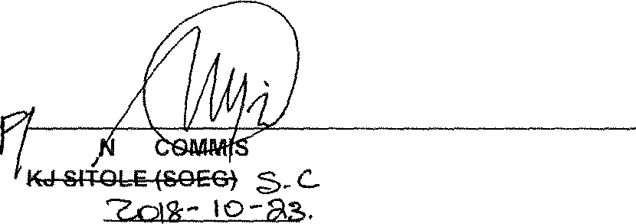GENERAL SERVICE
NATIO, AL
SIONER: SOUTH AFRICAN POLICE
DATE:

Reply to ques(ion 2941/ approved /

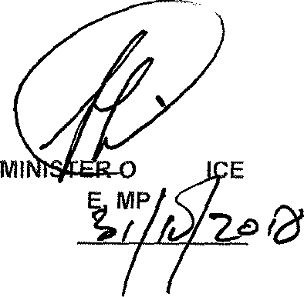
F POL
BH CEL DATE:

