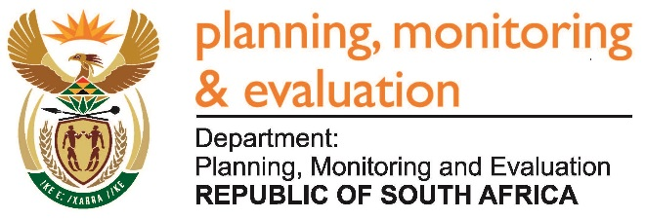 | 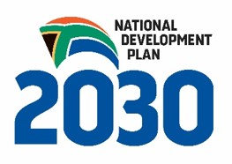
Private Bag X944, PRETORIA, 0001. Union Buildings East Wing, Government Avenue, PRETORIA
Tel: 012 312 0307. www.dpme.gov.za
_______________________________________________________________________________________
2941. Mr D J Maynier (DA) to ask the Minister in The Presidency:
Whether, with reference to his statement on the Mandate Paper for Budget 2018 on 7 September 2017, (a) the National Development Plan and/or (b) the Budget Prioritisation Frameworks have been adopted by other developmental states; if not, why not; if so, in each case, what (i) is the name of each country that adopted the specified frameworks and (ii) are the further relevant details in each case? NW3259E
Reply:
Development planning, which can be defined as national level, medium (5-year) to long-term (ten to 50 years) planning is common in what has been referred to as development states, especially in the so-called East Asian Tigers. Latin-America also has extensive planning systems.
Long-term and medium-term plans are developed in some key development states as follows:
In addition to a range of other planning instruments, Singapore’s rapid acceleration was accompanied by a Strategic Economic Plan which “sets the strategies and programmes for Singapore to realise a vision - to attain the status and characteristics of a first league developed country within the next 30 to 40 years.”
In South Korea, the Economic Planning Board was established in 1961 to develop economic plans and oversee their implementation. Five-year plans were developed with regularity from 1962 onwards.
Other developing countries and aspirant developmental states are also well-known for development planning. In 2006 the World Bank commented that Malaysia, one of the countries against which South Africa benchmarked its planning institutions, “has a rich history in long-term planning, having drawn up and implemented long-term national policy frameworks since the early 1970s. Since then, the Government has put into practice a comprehensive planning system of short-, medium- and long-term development plans and strategies, each linked to one another, reinforcing the course of policy directions toward meeting the long-term goals.”
In Chile the Ministry of Housing and Urbanism, in terms of the General Law on Urbanism leads planning through the National Urban Development Policy which provides principles, objectives and actions for the social, economic and territorial development of the country. Medium-term regional (“provincial”) plans, both development strategies defining broad socio-economic objectives for regions and more spatially orientated urban development strategies, are developed in terms of the national policy.
The Mexican national government develops a National Development Plan that is submitted to Parliament and approved and which sets the strategic objectives for the country. This is accompanied by a “General Ecological Spatial Plan” and these set the framework for state spatial developmental and ecological plans which develop strategic programmes for social, economic, cultural and environmental development and principles for land-use.
Brazil has a range of long and medium-term planning and budgeting mechanisms which are defined in its Constitution. For example, related to financing the Constitution specifies a multi-year plan (the “Plano Pluriannal” or “PPA”), the budgetary directives (“LDO”) and the annual budget (“LDA).
Budget Prioritisation Frameworks
Aligning budgets to plans and strategic priorities is critical for implementation of Government policy and plans. Due to contextual and institutional differences the exact mechanisms in different countries to align budgets and national strategic priorities, or a Budget Prioritisation Framework, differ substantially. In various jurisdictions. There is continuing experimentation with mechanisms for prioritisation and alignment. For example, in a 2016 World Bank Public Expenditure Review of Mexico it is recommended that to improve medium-term fiscal management there is a need to improve the links between “pluri-annual fiscal and investment planning and budgeting, managing mandatory expenditures, etc.” and for better “planning and budget integration” also through “developing a vision for the medium-term policy and program prioritization (enhancing the focus of planning, revising evaluation systems, selection of programs, etc)”.
With regard to some of the development states mentioned above:
In South Korea extensive processes are undertaken before budgets are drafted by line-ministries and Medium-Term Expenditure Framework task forces. As was reported in 2013: “The annual budget and MTEF cycle begins in January with line ministries and the Budget Office adjusting the ceilings from those of the previous year as a starting point and setting important policy priorities.”
In Singapore as part of the budget reforms since 1989, “the Cabinet decides on the budget priorities and the total allocations to the various sectors and ministries”.
For Malaysia, the World Bank in 2013 commented that “[i]n addition to defining the targets for the outlined public sector development programs, the five-year plans define the size and budgetary allocation for each of the respective programs over the plan period, effectively integrating the policy prioritization process with the budget allocation process.”
With reference to South and Latin America the bridge between plan and budget is most thoroughly institutionalised in Brazil where the Constitution describes a trilogy of instruments namely a multi-year plan, budget directives and the annual budget and the relationship between them.

