NATIONAL ASSEMBLY

FOR WRITTEN REPLY

QUESTION 2940

DATE OF PUBLICATION IN INTERNAL QUESTION PAPER: 19 OCTOBER 2018 (INTERNAL QUESTION PAPER NO 33-2018)
2s40. Dr P J Groenewald (FF Plus) to a•k die Minister of Police:

- What were the costs of the SA Police Service (SAPS) regarding court cases dealing with firearms during the period 1 January 2008 up ta the latest specified date for which information is available:

- (a) in which yesr each of the court oases took place, (b) what were the legal costs of the legal representatives of the SAPS in aach case, (c) whether the SAPS won or lost the case in each instance and ( d) what were the legal costs of the State with regard to the legal representatives of the othar parties;

- whether be will make a statement on the matter7
NW3251E

REPLY:

(1) & (2) Legal costs are paid by the Department of Justice d constitutional Development. Unfortunately the Department of Justice and Constitutional Oevelopmant does not breakdown the global monthly reimbursement claima and thus it is not possible to Indicate the amount of lagal costs paid for court cases dealing with firearms for If\e specified periods.
As the information thee in the domain of another department, Liz. the Department of Justice and Constitutional DBvRlopment, the information was ra ueated but to date no response is forthcoming.

DIVISIONAL
LIEUTENANT GENERAL fONER: LEGAL AND POLICY GERVICES

QUESTION 2940

Reply to question 2940 recommended / bed:

klEUTENANT GENERAL DEPUTY kATIO COMMl5BION£R: ASSET ANO LEGAL MANAG£IkENT FH VUMA

Reply to question 2940 recommended I not recommended-
l

ATI
GENERAL ONER: SOUTH AFRlCAft POLICE SERVICE

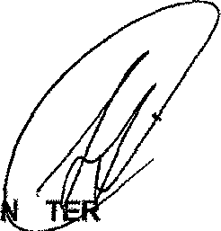
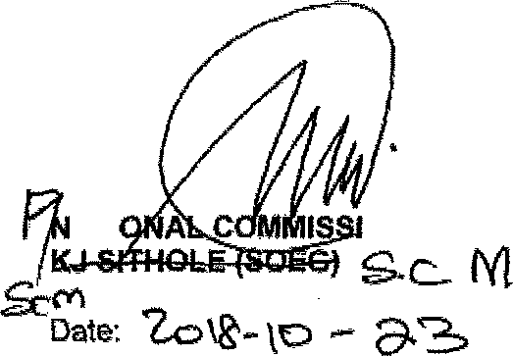
Reply to question 2940 approved /

MI iS OF POLICE BH CELE, MP

REPLY ORAL-TED BY : TEL. NO
DATE

NIAJ OEN EP GROENEWALD
(0t2) 3067068
201&1&24

