FOR WRITTEN REPLY

NATIONAL ASSEMBLY
36/1/4/1(201800283)

QUESTION 2939

DATE OF PUBLICATION IN INTERNAL QUESTION PAPER: 19 OCTOBER 2018 (INTERNAL QUESTION PAPER NO 33-2018)

2939. Dr P J Groenewald (FF Plus) to ask the Minister of Police:

With reference to his answer to question 2719 on 2 October 2018, (a) what kind of explosive substances did the SA Police Service find on the Russian ship and (b) what amount of each kind of explosive substance was found on board of the specified ship?
NW3250E
REPLY:

The information cannot be provided, as the security of the countries and the vessel will be compromised, if a public statement is made to this effect.

Reply to question 2939 recommended/

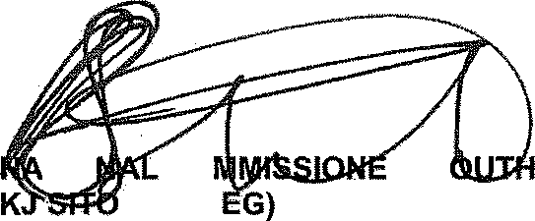
GENERAL AFRICAN POLICE SERVICE
TIO
CO LE (SO
R: S

Date: f018 -)T- 15

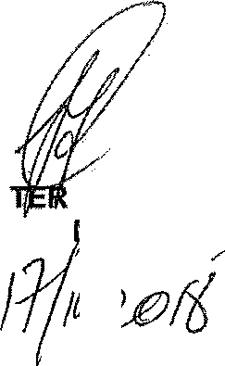
Reply to question 2939 approved/n

MINIS OF POLICE BH CELE, gP
Date: '/

FOR WRITTEN REPLY
QUESTION 2Y19

NATIONAL ASSEMBLY
36/1/4/1(201800259)

DATE OF PUBLICATION IN INTERNAL QUESTION PAPER: 7 SEPTEMBER 2018 fINTERNAL QUESTION PAPER NO 29-2018)

2719. Dr P J Groenewald (FF Plus) to asH the Minister of Police:
- Whether the SA Police Service has searched any Russian ship for weapons of mass destruction under the Explosive Substances Act, Act 26 of 1956, and/or the Non-Proliferation of Weapons of Mass Destruction, Act 87 of 1993; if so, what is the name of the ship;

- whether any such material has been found in accordance with the specified two Acts; if so, what substances have been found;

- whether any arrests have been made; if not, why not; if so, what number of

arrests has been made;

- whether he will make a statement on the matter?
REPLY:
- Yes, It was a Russian cargo vessel.

NW3014E

Yes, it was found that there were containers carrying explosiVes and the necessary permits were in place.

- No, the permits were available.

- No, the security of the countries and the vessel will be compromised, if a public statement is made to this effect.

Reply to question 2719 recommended

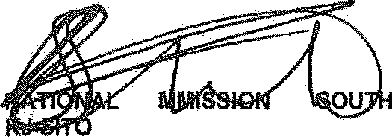
GENERAL AFRICAN POLICE SERVICE
CO
LE (SOEG)
ER:

Date: ]g18 -IU- é

QUEBT3ON 2930
DATE OF PUBLICATIDN IM {N NAL QUESTION PAPER: 18 OCTOBER 2g18 f!NTERNAL QUESTION PAPER NO 33-2018F
NATIONAL A8SENIBLY 36/1/4f1(2018)
FOR WRITTEN REP1Y QUESTION gB39
DATE OF PUBLICAT! N IN INTERNAL QUESTION PAPER: 19 OCTOBER 2016
(INTERNAL QUESTION PAPBR NO 39-2018)

2939. Dr P J Groenewald (FF Plua) to ask the Minister of Polica:
W‹th reference to hb an9wer to qucs9on 2718 on 2 October 2018. ta) what kind of explosive substances the SA Police Service found on the Russian ehlp and (b) what amount of each kind of explosive substance was found on board the specified ship?

NW3250E
REPLY:
Information cannot be provided as the security of the count‹tes and the vessal will be
compromised tfa public statemant ie made to this affect.

LIEUTENANT GENERAL

IONER: OPERATIONAL RE6PONSE SERVICES

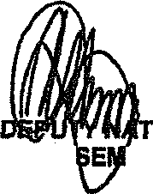
Roply to question 2838 recommended/dded

LIEUTENANT GENERAL
IONAL COMMISSIONER: POLIC!NG
SF MA OLA

