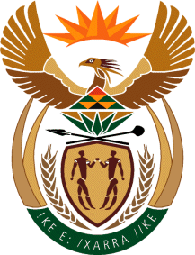
MINISTRY
SPORT AND RECREATION
REPUBLIC OF SOUTH AFRICA

Department of Sport and Recreation l Private Bag X896 l PRETORIA l 0001 l Regent Place l 66 Queen Street l Pretoria l 0001 l +27 (0)12 304 5158 l Fax: +27 (0)12 323 8426
Private Bag X9149 l Cape Town l 8000 l 2nd Floor Parliament Building l 120 Plain Street l CAPE TOWN l Tel: +27 21 469 5705 l Fax: +27 21 465 4402
www.srsa.gov.za
_____________________________________________________________________

NATIONAL ASSEMBLY

WRITTEN REPLY

QUESTION PAPER: No. 34 of 06 OCTOBER 2017

DATE OF REPLY: 27 NOVEMBER 2017

2938. Mr. D Bergman (DA) asked the Minister of Sport and Recreation:
(1) Whether he has found that there is a conflict of interest in respect of the alleged use by the SA Football Association (SAFA) of their own vehicles to shuttle voters of a certain political party (name furnished) during recent by-elections in areas in the Western Cape, Northern Cape and Eastern Cape;

(2) whether he has been informed of whether the SAFA board approved the specified expenses? NW3255E
______________________________________________________________________

The Minister of Sport and Recreation

REPLY:

(1) We are not aware of such an incident. However, if true, the Honourable Member will be aware that, in line with the Olympic Charter, the national Department of Sport and Recreation is not allowed to interfere with the administration of the federations. It may be useful for the Honourable member to bring this matter to the attention of the relevant competent authority, that being the Independent Electoral Commission (IEC) of South Africa.

(2) No.

