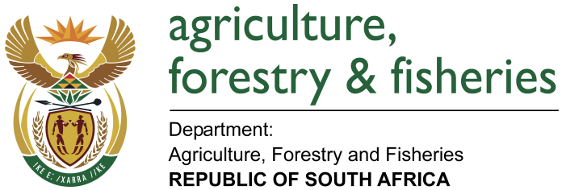
NATIONAL ASSEMBLY

WRITTEN REPLY

QUESTION 2934 / NW 3251E E

MINISTER OF AGRICULTURE, FORESTRY AND FISHERIES:
Ms A Steyn (DA) to ask the Minister of Agriculture, Forestry and Fisheries:

QUESTION:
(1) Whether the World Organisation for Animal Health (OIE) sent a delegation to South Africa in September 2017 to look at the export of game meat; if so, what are the full details;
(2) whether the findings will be made available publicly; if not, why not; if so, on what date;
(3) how far is his department in implementing the recommendations made by the OIE during its previous visit to South Africa;
(4) whether any plans have been put in place to ensure that South Africa maintains its game meat export status; if not, why not; if so, what are the relevant details?

REPLY:
- A delegation from the European Commission, and not the World Organisation for Animal Health, visited South Africa from 4 to 15 September 2017 to evaluate the animal health controls related to the export of game meat, with particular emphasis on Foot and Mouth Disease (FMD) controls. Following an outbreak of FMD in the FMD free zone of South Africa in 2011, the export of game meat to the EU was suspended by the EU. South Africa regained its FMD free zone status in 2014 and subsequently invited the EU to perform the required inspection visit to consider re-opening the market.

- The normal procedure following such a visit is for the inspection team to send a draft report to South Africa for factual corrections, where-after the final report will be published on the EU website. The findings will therefore be available publicly, but the exact date when this will happen is not within the control of the Department.
- As indicated in 2 above, the report of the EU mission is awaited which will include specific recommendations. However, DAFF is continuously working on implementing the OIE guidelines (on FMD) in order to ensure continued maintenance of the FMD free zone status.

- Currently, there are no exports of game meat to the EU due to the 2011 ban. The EU report from the recently concluded mission will contain their decision with regards to re-opening the market for the export of game meat, along with their recommendations for South Africa to regain and maintain this market. Corrective actions, as appropriate, will be put in place accordingly to ensure that the available resources are used optimally where they will have the most significant impact.

