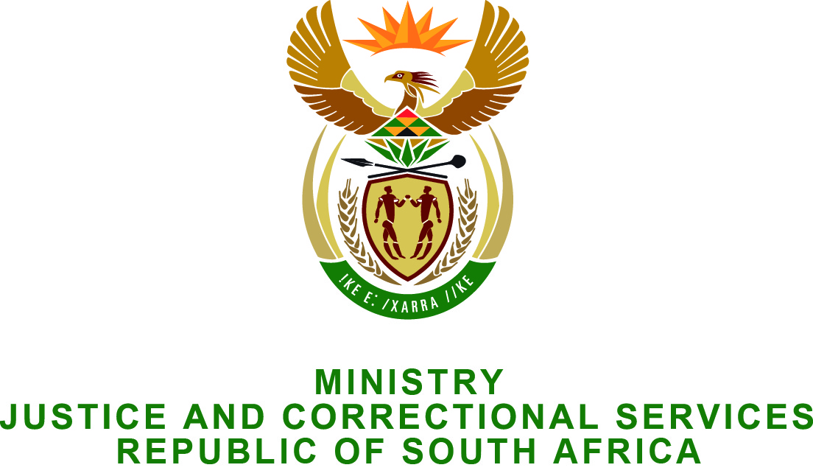

NATIONAL ASSEMBLY
QUESTION FOR WRITTEN REPLY
PARLIAMENTARY QUESTION NO.: 2930
DATE OF QUESTION: 14 AUGUST 2015
DATE OF REPLY: 28 AUGUST 2015

Adv A de W Alberts (FF Plus) to ask the Minister of Justice and Correctional Services:
(1) Whether, given the fact that the investment protection agreement between South Africa and Zimbabwe does not retroactively provide for the protection of property rights of South African citizens against expropriation and/or illegal occupation before the commencement of the agreement, he will consider introducing legislation to Parliament to bring about compensation for such disadvantaged people by making the confiscation of assets of the Zimbabwean government and/or responsible ministers and/or officials in South Africa possible; if not, why not, seen against the background of the Bill of Rights contained in the Constitution of the Republic of South Africa, 1996, and relevant international law; if so, what are the relevant details; and
(2) What steps will he take regarding the unlawful dispossession of South African citizens’ property rights in Zimbabwe by the Zimbabwean government and/or illegal occupiers? NW3433E

REPLY:
(1) I wish to inform the Honourable Member that neither the Department of Justice and Constitutional Development, nor the South African Law Reform Commission, has such pending legislation or research projects, in process.
(2) As the matter relates to international property rights, which are not in the jurisdiction of the Republic of South Africa, I would recommend that the Honourable Member address such question to the Minister of International Relations and Cooperation.

