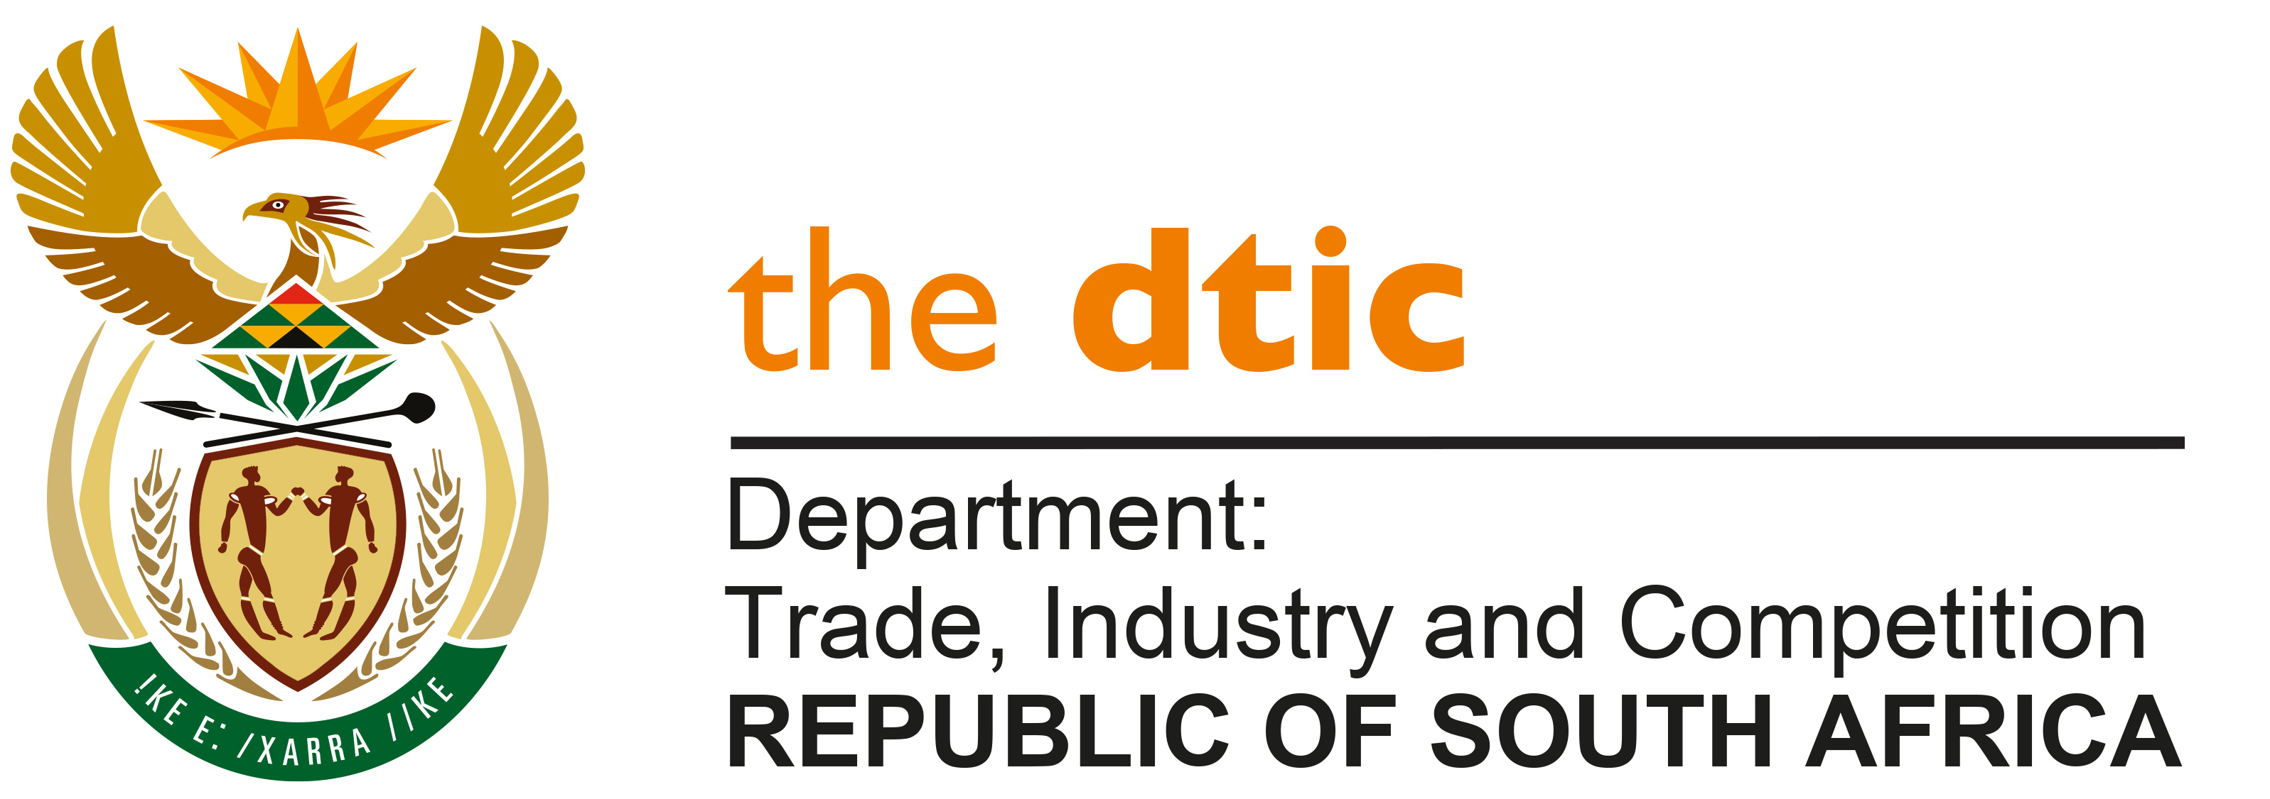

THE NATIONAL ASSEMBLY

QUESTION FOR WRITTEN REPLY

QUESTION NO. 2927

DATE PUBLISHED: 9 SEPTEMBER 2022

Inkosi R N Cebekhulu (IFP) to ask the Minister of Trade, Industry and Competition:

With reference to the European Union’s claims that the Republic’s temporary ban on the export of scrap metal is not aligned to the trade deals of the World Trade Organisation (WTO), what further steps has his department and/or the Government taken to (a) illustrate that ban of scrap metal is in line with the position of other states that have banned the sales of scrap metal and (b) ensure that it is not in contravention of WTO agreements in this regard? NW3553E

REPLY:

South Africa’s infrastructure is being stripped at an unprecedented rate with a substantially negative impact on government, citizens and the economy. The objective of the proposed measures (which include prohibition on scrap metal) is likely to lead to a material reduction in the theft of metal from the country's infrastructure. The details setting out the rationale for and proposed modalities of such restriction, were published in the Government Gazette for public comment.

Over the past decade research has pointed to 26 developing and developed countries (the latter including the European Union) who have imposed different forms of restrictions on the export of scrap metal for a variety of reasons, including environmental reasons or to ensure domestic supply. Some countries have imposed export restrictions on scrap metal to curb criminality and the destruction of infrastructure.

Government has consulted with external lawyers regarding the legality of the proposed measures and believe them to be compliant with international trade obligations.

-END-

