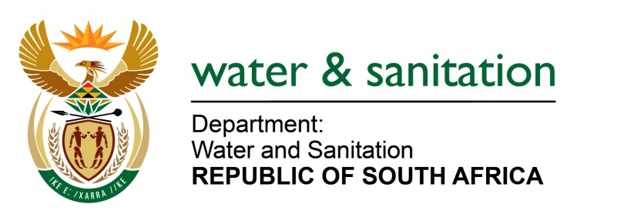

NATIONAL ASSEMBLY

FOR WRITTEN REPLY

QUESTION NO 2913

DATE OF PUBLICATION IN INTERNAL QUESTION PAPER: 14 AUGUST 2015
(INTERNAL QUESTION PAPER NO. 30)

2913. Ms J M Maluleke (ANC) to ask the Minister of Water and Sanitation:

Whether, with reference to the delegation of the former Minister of Water and Environmental Affairs by the President, Mr Jacob G Zuma, in response to a letter written by a resident from Ngobi regarding a water crisis in the specified area, she undertook a follow-up intervention since her appointment; if so, what progress has been made in resolving the specified water crisis?
---00O00---
REPLY:

The Moretele Local Municipality (LM) has implemented and completed the upgrade of the Transactie Well Field water supply augmentation project which consists of a 10 km pipeline, chlorination house, equipping 10 boreholes, 10 pump house structures and 2.5 mega litres per day (Ml/day) reservoir. The total cost of the project amounted to R11 million. This project has increased the water storage capacity in the area from 0.35 Ml to 2.85 Ml (an increase of 2.5 Ml). The system is currently operational and people are receiving water, though the water supply source is not sufficient to deal with the current demand. To augment water supply in the area of the Moretele LM is providing tankering until a lasting and sustainable solution is found.

Long Term Plan

On 16 July 2014; my Department, the Moretele LM and Magalies Water signed a tripartite agreement to conduct a study for bulk water supply in Moretele including the Moretele North Portion. The study is at an advance stage, whilst the Moretele South is under Construction in Klipdrift and the Moretele North is under detail design which incorporates the entire Ngobi Village through the supply from Klipvoor.

---00O00---

