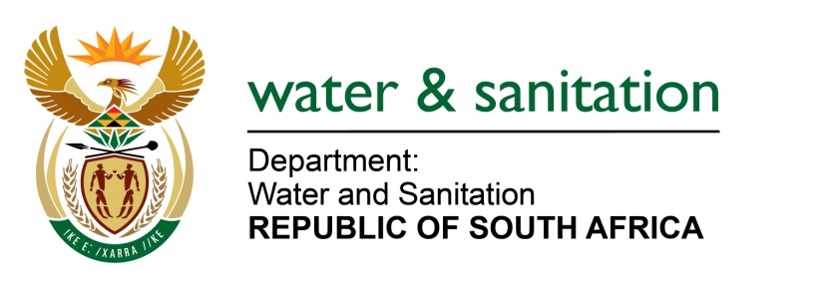

NATIONAL ASSEMBLY

FOR WRITTEN REPLY

QUESTION NO 2912

DATE OF PUBLICATION IN INTERNAL QUESTION PAPER: 14 AUGUST 2015
(INTERNAL QUESTION PAPER NO. 30)

2912. Ms C N Majeke (UDM) to ask the Minister of Water and Sanitation:
(1) Whether she has been informed of the water crisis in Greenville Village, in Mthatha, which has been without water for more than four weeks; if so, what plans has her department put in place to resolve the specified crisis; if not,
(2) whether her department intends to investigate the situation with an intention to (a) resolve the crisis and (b) ensure that water is provided? NW3415E
---00O00---
REPLY:

- My Department has not been informed of the water crisis in Greenville Village, in Mthatha which has allegedly been without water for more than four weeks.

- Upon receiving of this question, my Department’s Provincial Office: Eastern Cape investigated the matter and found out that water supply to Greenville Village was deliberately switched off by the O R Tambo District Municipality due to non-payment of water bills and there is nothing wrong with the water supply system. This area consists of government properties with some informal dwellings built around the houses. However, the OR Tambo District Municipality is carting water to the informal settlement of Kwa-Mpuku which is adjacent to the formal settlement. They have since put two Jojo tanks which are filled timeously. It will be further investigated if the houses are occupied legally which would enable Public Works to pay for the services rendered.

---00O00---

