MEMORANDUM FROM THE PARLIAMENTARY OFFICE
NATIONAL ASSEMBLY
FOR WRITTEN REPLY
QUESTION 2911
DATE OF PUBLICATION OF INTERNAL QUESTION PAPER: 09/09/2022
INTERNAL QUESTION PAPER NO 31 OF 2022
Mr S S Zondo (IFP) to ask the Minister of Higher Education, Science and Innovation
(1) Whether, with reference to the Women’s Month Roundtable where he pointed out that 10% of all rape cases take place in universities, his department has regulations in place in terms of processes and procedures that serve as guidelines on how universities deal with Gender-Based Violence and rape cases; if not, what is the position in this regard; if so, what are the details thereof;
(2) whether his department follows up on cases reported to the university to ensure that the processes it follows are equitable and sensitive to victims; if not, why not; if so, what practices of accountability are there from his department to ensure that cases are handled correctly;
(3) whether his department offers any legal and/or psychological support to victims going through university-led legal processes; if not, why not; if so, what are the relevant details? NW3537E

REPLY:
Addressing the occurrence of GBV forms part of integrated Gender Equality functions in the Department of Higher Education and Training (the Department), under the umbrella of Social Inclusion across all branches. Every branch, in this case the University Education and Planning, Policy and Strategy branches each have unique responsibilities. These include for the University Education branch:
- Create the enabling environment, coordinate, support institutions in the implementation of social inclusion in the PSET system;
- Manage the institutional policy environment; and
- Manage and support implementation programmes within institutions.
The Planning, Policy and Strategy branch is responsible for:
- Develop and manage the enabling policy environment (including sector policies, guidelines, standards, protocols and tools) for social inclusion in the PSET system;
- Support (where needed) implementation branches in the implementation of Social Inclusion and Equity;
- Collate information from Branches and monitor the implementation of social inclusion policies and programmes in the PSET system;
- Report on the implementation of social inclusion in the PSET system;
- Liaise with Chapter 9 institutions, other Departments; and
- Report on national and international obligations.
(1) In order to create the enabling environment to address GBV and rape cases in Universities the Department has published the Policy Framework to address Gender-based Violence in the Post-School Education and Training System (Government Gazette No 43575, 31 July 2020). The purpose of the Policy Framework is to create an enabling environment for the eradication of GBV and instil respect, protection, promotion and fulfilment of human rights as enshrined in the Bill of Rights of the Constitution of the Republic of South Africa (Act No 108 of 1996). The Policy Framework intends to assist PSET institutions to address the occurrence of GBV and to provide a monitoring instrument to the Department to assess the implementation of the Policy Framework.
The Policy Framework aims to:
- Conceptualise GBV and define its manifestation in terms of existing laws and policies;
- Detail the international and national regulatory framework compelling institutional and departmental responses to GBV;
- Provide guidance around the structures, mechanisms and processes that PSET institutions must put in place to address GBV;
- Compel PSET institutions to both create awareness of GBV policies and prevent incidents of GBV; and
- Set out a framework for oversight of the DHET and PSET institutions’ development and implementation of policy.
The Policy Framework has 3 strategic objectives, including:
- Create an enabling environment in the Department and PSET institutions to ensure the effective implementation of the Policy Framework, actions and programmes;
- Promote the safety of all students and staff by putting in place comprehensive prevention and awareness programmes intended to raise the importance of policies and services addressing GBV, as well as other measures aimed at preventing incidents of GBV; and
- Provide comprehensive support, assistance to victims and refer them appropriately to specialised support and assistance in line with the National Instructions, National Directives, List of Designated Health Establishments and Additional Services directives under the Sexual Offences and Related Matters Act (SORMA) (Act 32 of 2007).
It is the responsibility of PSET institutions to implement the Policy Framework with the support of the Department and HIGHER HEALTH.
Following the release of the Policy Framework and as part of its work, the Ministerial Task Team on GBV in Universities held a series of engagements with university communities across various institutions. Amongst others the aim was to establish how universities respond to sexual harassment and GBV and harm, and what support is needed from the Department to enable effective implementation of the Policy Framework.
It has been established that not all universities have sufficient means to deal with GBV, and the Department and HIGHER HEALTH aim to support these universities and campuses in addressing the problem. The Ministerial Task Team, as soon as the report is released. will advise on areas requiring improvement in institutional responses to GBV violence and sexual harassment and appropriate levels of support needed for the implementation of the National Policy Framework to address gender-based violence by universities.
The Department furthermore plays an oversight role, monitoring institutions to ensure that they take full responsibility for addressing GBV on their campuses.
The Department supports institutions in implementation, monitors the implementation of the Policy Framework and is now finalising the Social inclusion Review and Implementation Model (SI-RIM) that is a mechanism to provide information on what to include in addressing GBV and also for reporting purposes.
The Department, HIGHER HEALTH, in collaboration with several Departments (such as Health, Justice and Constitutional Development, South African Police Service (SAPD) and others), experts and institutions developed institutional implementation Guidelines and supporting protocols and standards for Institutions to address GBV.
HIGHER HEALTH, through the Department has furthermore released a set of instruments that will strengthen the realisation of the Policy Framework. These instruments include directives to all institutions and Management to put the necessary infrastructure towards a comprehensive response on cases of sexual and gender misconduct, rape, sexual assaults across all our campuses. The procedural guidelines and protocols on rape, code of ethics ensure that reporting of cases, disciplinary systems, safeguarding evidence, provision of rape kits, psychosocial support services and survivor friendly infrastructure is developed across campuses.
The Department is supporting institutions to develop and implement policies and protocols on GBV. All universities have measures in place to raise awareness, and offer guidance and advice on GBV related matters. These include, but are not limited to: workshops or presentations during orientation weeks and during various parts of the year for students; roadshows; training; production and dissemination of brochures and other literature for the university community; and information on institutional websites. In addition to these initiatives, a large number of students have completed a curriculum on GBV prevention and mitigation via HIGHER HEALTH, empowering them with knowledge and understanding of GBV and related matters. Higher Health is the Department’s implementing agency for student health, wellness and development in the post-school sector.
(2) The Department through HIGHER HEALTH follows up on cases reported to the university to ensure that the processes it follows are equitable and sensitive to victims.
HIGHER HEALTH provides psycho-social support services through two main modalities: (1) through the HIGHER HEALTH toll-free helpline, and (2) through interventions provided by counselling and clinical psychologists. HIGHER HEALTH is also providing support to victims through trained mentors and they are also running a comprehensive awareness programme through several focussed campus activities, campus radio programmes and peer support mechanisms.
HIGER HEALTH works closely with psychosocial support structures on and off-campus. Victims are supported on campus through trained mentors and staff, as well as specialist support personnel such as counselling and clinical psychologists. They also assist victims through the reporting processes and refer them to specialist psychosocial support off-campus. Thorough follow-up is being made to support victims throughout the process of reporting and rehabilitation.
HIGHER HEALTH is implementing a comprehensive and integrated programme promoting health and wellbeing of students across South Africa’s public universities and TVET colleges and provide on-campus support to PSET institutions in 7 priority areas:
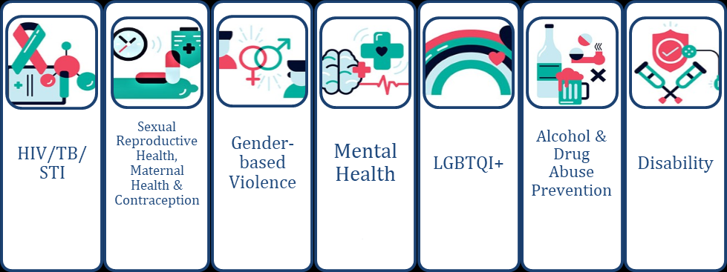
This year, over 14 000 students accessed the various HIGHER HEALTH models of psychosocial support. Academic stress and anxiety (30%), general stress and substance abuse (22%) depression and suicide (18%) and sexual, physical and emotional abuse (19%) present the main reasons for accessing support care.
HIGHER HEALTH has set up campus and community radio stations to engage young students routinely on matters related to Sexual and Gender Based Violence and mental health as a matter of priority. There is also HIGHER HEALTH's 24-hour toll-free helpline available in all 11 official languages. The line offers health, wellness and psychosocial risk assessment toolkits for early screening, empowerment and referral related to gender-based violence, mental health, HIV, TB and other matters.
(3) Through HIGHER HEALTH he Department offers legal and/or psychological support to victims going through reporting and legal processes. Universities also have their own systems and processes to support students and staff in these areas.

