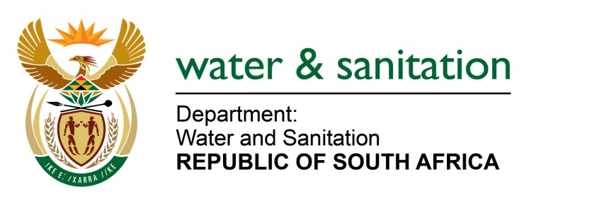

**Annexure B**

**Breakdown for the CMAs**:

|  |  |  |  |  |  |
| --- | --- | --- | --- | --- | --- |
| **Inkomati-Usuthu CMA** | **0-3 months** | **3-6 months** | **6-12 months** | **12 months** | |
| (a)(aa)(aaa) Breakdown of listed assets directly held | Current Assets  Trade and other receivables from exchange transactions:  R 407,86  Cash and cash equivalents (Money at the bank as at 31 March 2017: R  33,812,637 |  | Buildings:  R 1,321,080  Furniture and fixtures:  R 972,295  Motor vehicles:  R 654,888  Office equipment:  R 1,102,465  Computer equipment :  R 1,542,611  Property details: Office Building in Portion 1 of Erf 32 Mkhondo Municipality Purchase price: R 20 October 20161,351,252 | The only receivable beyond 12 months is the rental deposits on the leased office space. | |
| (a)(bbb)  Breakdown of listed assets indirectly held | None |  | None | None | |
| (b) Valuation for current and non-current assets | R 441, 672,637 |  | R 9892 854 |  | |
| (b)(bb)(aaa) unlisted investments directly held | None |  | None | None | |
| (b)(bb)(bbb) unlisted investments indirectly held | None |  | None | | None |

|  |  |  |  |  |
| --- | --- | --- | --- | --- |
| **Breede-Gouritz CMA** | **0-3 months** | **3-6 months** | **6-12 months** | **12 months** |
| (a)(aa)(aaa) Breakdown of listed assets directly held | None |  | Current assets  Rental deposit:  R 211 307.42  Debtors:  R 2 299.35  Bank Account:  R1 075 577.65  Petty Cash  R 2 210.60 | Non-Current Assets (Net book value)  Motor Vehicles:  R1 793 091.65  Computer Equipment:  R1 640 733.70  Computer Software:  R 445 625.34  Office Equipment:  R 300 786.98  Furniture:  R 902 534.81  Scientific equipment R 95 834.34  Leasehold Improvements:  R 436 566.05 |
| (a)(bbb)  Breakdown of listed assets indirectly held | None |  | None | None |
| (b) Valuation for current and non-current assets | None |  | R 1 291 395 | R 5 519 338 |
| (b)(bb)(aaa) unlisted investments directly held | None |  | None | None |
| (b)(bb)(bbb) unlisted investments indirectly held | None |  | None | None |

**Breakdown for the Water Boards:**

| **(ii) Entity** | **What is the detailed (a) breakdown of (b) valuation for current and non-current assets and investments held** **by each entity?** | **(aa) listed assets** | | **(bb) unlisted investments** | |
| --- | --- | --- | --- | --- | --- |
|  | | **(aaa) directly held** | **(bbb) indirectly held** | **(aaa) directly held** | **(bbb)**  **indirectly held** |
| **Amatola Water** | (a) n/a  (b) n/a | n/a | n/a | n/a | n/a |
| **Bloem Water** | (a) See the attached below  (b) ) See the attached below | none | none | none | none |
| **Lepelle Northern Water** | 2016/17  (a)Current Assets- R1,001,200  (b)Non-current Assets-R772,400 | none | none | Stanlib R22,679,863.81  Investec Money Market  R18,496,564.90  Investec call account  R986,985.07  FNB call Account  R108,020,714,38  FNB cheque Account  R1,986233.00 | none |
| **Magalies Water** | (a) See the attached **Annexure B** below  (b) See the attached **Annexure B** below | none | none | R420 103M | none |
| **Mhlathuze Water** | (a) See the attached **Annexure C** below.  (b) See the attached **Annexure C** below. | n/a | n/a | n/a | n/a |
| **Overberg Water** | (a) See the attached **Annexure D** below  (b) See the attached **Annexure D** below | n/a | n/a | 27 874 086 | n/a |
| **Rand Water** | See the attached **Annexure E** below | See the attached **Annexure E** below | See the attached **Annexure E** below | See the attached **Annexure E** below | See the attached **Annexure E** below |
| **Sedibeng Water** | (a) See the attached **Annexure G** below  (b) See the attached **Annexure G** below | n/a | n/a | n/a | n/a |
| **Umgeni Water** | See the attached **Annexure H** below | See the attached **Annexure H** below | See the attached **Annexure H** below | See the attached **Annexure H** below | See the attached **Annexure H** below |
| **TCTA** | (a) See the attached **Annexure F**  (b) (a) See the attached **Annexure F** | See the attached **Annexure F** | See the attached **Annexure F** | See the attached **Annexure F** | See the attached **Annexure F** |
| **WRC** | (a) None  (b) No listed and non-listed investments | No investments directly | No investments indirectly held | No investments directly | No investments indirectly held |

**Bloem Water**

|  |  |  |  |  |
| --- | --- | --- | --- | --- |
|  |  | 2017 |  | 2016 |
|  |  | R’000 |  | R’000 |
| Assets |  |  |  |  |
|  |  |  |  |  |
| Non-current assets |  | 825 276 |  | 858 761 |
|  |  |  |  |  |
| Property, plant and equipment |  | 776 761 |  | 828 627 |
| Defined benefit asset |  | 48 515 |  | 30 134 |
|  |  |  |  |  |
| Current assets |  | 439 242 |  | 471 612 |
|  |  |  |  |  |
| Inventories |  | 13 272 |  | 12 238 |
| Trade and other receivables |  | 219 519 |  | 96 267 |
| Cash and cash equivalents |  | 134 067 |  | 235 971 |
| Infrastructure project receivable |  | 72 384 |  | 127 136 |
|  |  |  |  |  |
|  |  |  |  |  |
| *Total assets* |  | 1 264 518 |  | 1 330 373 |

|  |  |  |  |  |  |  |  |  |  |  |
| --- | --- | --- | --- | --- | --- | --- | --- | --- | --- | --- |
|  |  | | | | 2017 | |  | | 2016 | |
|  |  | | | | R’000 | |  | | R’000 | |
|  | Trade and other receivables | | | |  | |  | |  | |
|  |  | | | |  | |  | |  | |
|  | Trade receivables | | | | 208 989 | |  | | 89 929 | |
|  |  | | | |  | |  | |  | |
|  | Total trade receivables | | | | 662 864 | |  | | 297 250 | |
|  | *Less:* Provision for impairment | | | | (453 875) | |  | | (207 321) | |
|  | Personnel advances | | | | 38 | |  | | - | |
|  | Other project receivables | | | | 1 096 | |  | | 993 | |
|  | Deposits – Eskom and Centlec | | | | 9 395 | |  | | 5 345 | |
|  |  | | | |  | |  | |  | |
|  |  | | | | 219 519 | |  | | 96 267 | |
|  |  | | | |  | |  | |  | |
|  |  | *Gross* | *Impairment* |  | | *Gross* | | *Impairment* | |
|  |  | 2017 | 2017 |  | | 2016 | | 2016 | |
|  |  | R’000 | R’000 |  | | R’000 | | R’000 | |
|  | At 30 June 2017, the age analysis for trade receivables is as follows: |  |  |  | |  | |  | |
|  |  |  |  |  | |  | |  | |
|  | Not past due | 100 713 | 94 674 |  | | 64 528 | | 12 957 | |
|  | Past due 30 to 60 days | 65 856 | 21 185 |  | | 43 190 | | 5 817 | |
|  | Past due 60 to 90 days | 70 242 | 69 832 |  | | 44 684 | | 44 684 | |
|  | Past due more than 90 days | 426 053 | 268 183 |  | | 144 848 | | 143 863 | |
|  |  |  |  |  | |  | |  | |
|  | Total | 662 864 | 453 875 |  | | 297 250 | | 207 321 | |

Based on historical default rates, the entity believes that no additional impairment allowances are necessary in respect of trade receivables. The past due amounts not impaired have been received subsequent to year-end.

|  |  |  |  |
| --- | --- | --- | --- |
|  | **Cash and cash equivalents** |  |  |
|  |  |  |  |
|  | ABSA Bank* | 20 000 | 40 000 |
|  | Nedbank* | 20 004 | 50 298 |
|  | Investec* | 21 564 | 70 432 |
|  | Current account – First National Bank | 6 934 | 4 397 |
|  | Call account – First National Bank | 22 777 | 31 146 |
|  | Money Market account – Standard Bank | 42 767 | 39 678 |
|  | Petty cash on hand | 20 | 20 |
|  |  |  |  |
|  |  | 134 067 | 235 971 |

*These investments are held on call deposit accounts, which are all fixed for 3 months or less. The investments are not actively traded and are carried at amortised cost.

**Magalies Water**

Non-current assets – Property, Plant and equipment and Intangible assets

Current assets – Financial Assets (investments), Inventories, Trade and other receivables and cash and cash equivalents.

|  |  |
| --- | --- |
| **Non-current assets** | **As at 31 August 2017**  **R-value (R’000)** |
| **Non-current assets** |  |
| Property, Plant and equipment | R2 668 212 |
| Intangible assets | R35 850 |
| **Current assets** |  |
| Financial Assets | R98 439 |
| Inventories | R23 770 |
| Trade and other receivables | R267 078 |
| Cash and cash equivalents | R30 816 |

(ii) Current assets value as at 31 August 2017 is R420 103M

(aa) Listed assets – none

(bb) Unlisted assets – R420 103M

(aaa) Directly held – R420 103M

|  |  |  |  |  |
| --- | --- | --- | --- | --- |
| Current Assets | 0 – 3 months  R’000 | 3 – 6 months  R’000 | 6 – 12 months  R’000 | > 12 months  R’000 |
| Investments | R98 439 |  |  |  |
| Inventories | R23 770 |  |  |  |
| Trade and other receivables | R175 592 | R12 233 | R10 328 | R68 925 |
| Cash and cash equivalents | R30 816 |  |  |  |

(bbb) Indirectly held – none

**Mhlathuze Water**

**Table A – Breakdown of investment held by Mhlathuze Water as at 30 June 2017**

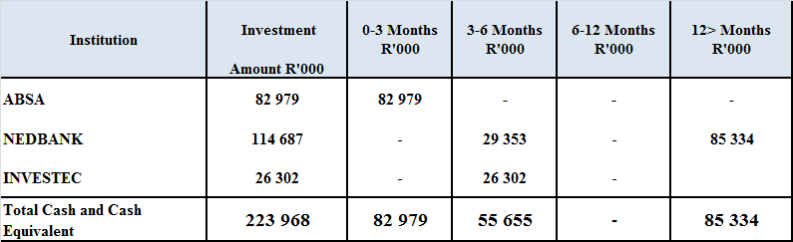

**Table B- Breakdown of Current and Non -Current Asset as at 30 June 2017**



**Overberg Water**

Current Assets comprises of:

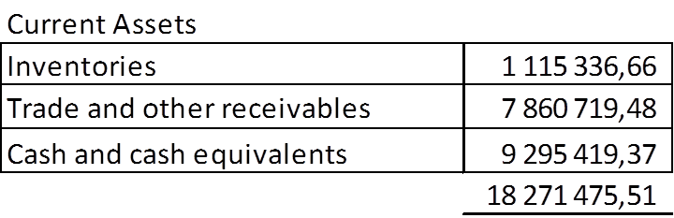

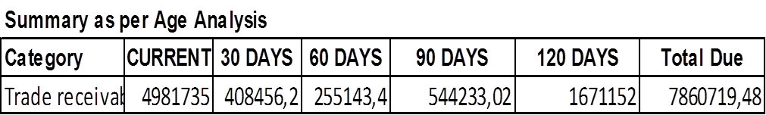

Non- Current investments:

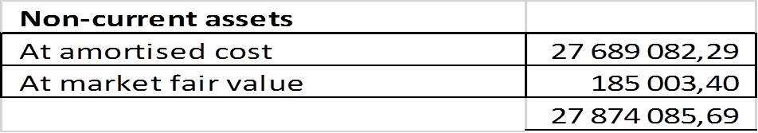

Non – Current Assets:

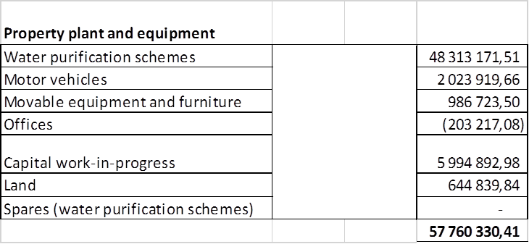

**Rand Water**

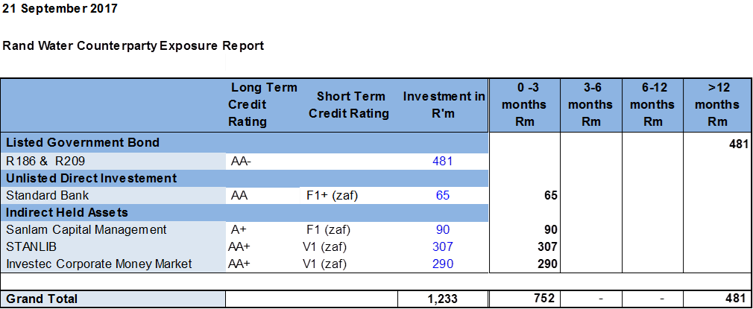

**Umgeni Water**

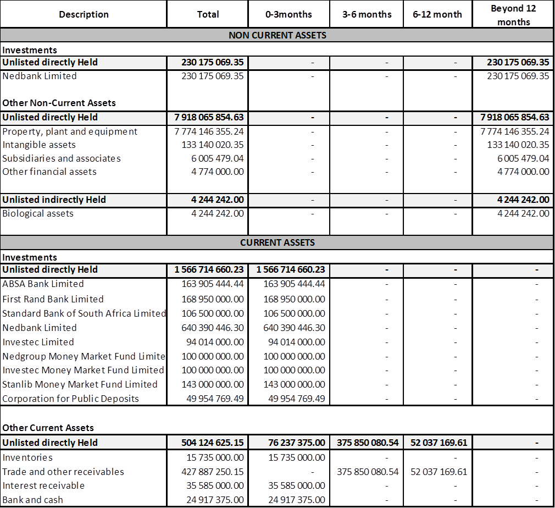



TCTA



---00O00---