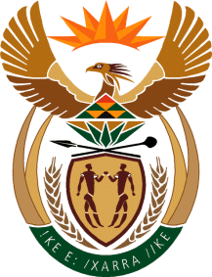

MINISTRY OF TOURISM
REPUBLIC OF SOUTH AFRICA

Private Bag X424, Pretoria, 0001, South Africa. Tel. (+27 12) 444 6780, Fax (+27 12) 444 7027
Private Bag X9154, Cape Town, 8000, South Africa. Tel. (+27 21) 469 5800, Fax: (+27 21) 465 3216

NATIONAL ASSEMBLY:

QUESTION FOR WRITTEN REPLY:
Question Number: 2904
Date of Publication: 27 November 2020
NA IQP Number: 50
Date of reply: 16 December 2020

Mr M S F de Freitas (DA) to ask the Minister of Tourism:
(1) (a) On what date did she sign her performance contract, (b) how often is her performance assessed and reviewed and (c) what are the details of her performance results to date;
(2) what are (a) her main Key Performance Indicators in her performance contract and (b) the (i) measurables and (ii) deadlines in each case?
NW3729E
REPLY:
President Cyril Ramaphosa has signed performance agreements with all Ministers to strengthen the capacity of the State and increase accountability.
These agreements, which are based on the targets contained in the Medium-Term Strategic Framework – have been made public so that the people of South Africa can hold those who they elected into office to account.
Copies are available at: https://www.gov.za/about-government/government-system/ministers-performance-agreement.

