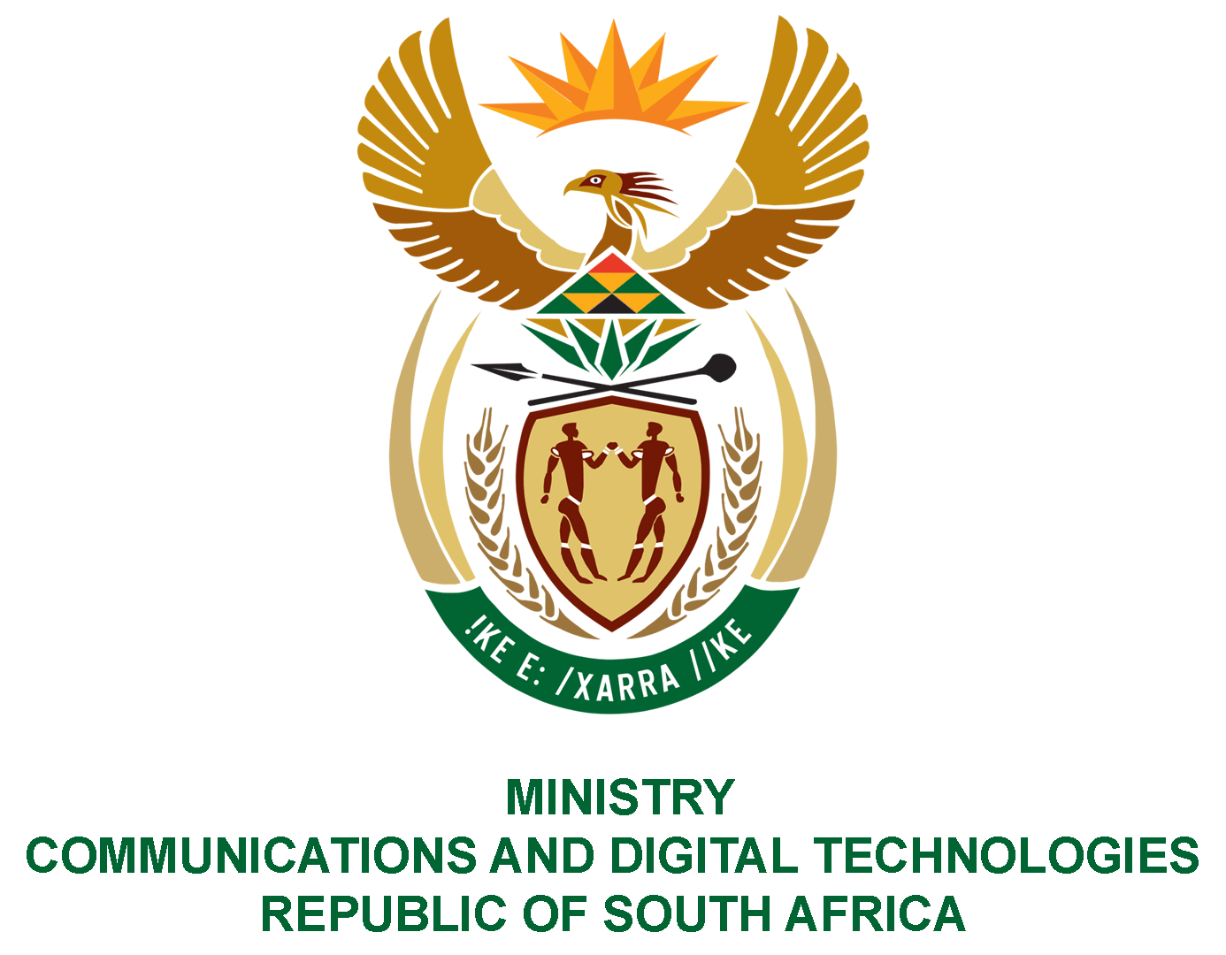

PARLIAMENT OF THE REPUBLIC OF SOUTH AFRICA
NATIONAL ASSEMBLY
WRITTEN REPLY

QUESTION NO: 2903
DATE OF PUBLICATION: SEPTEMBER 2022
QUESTION PAPER NO: 31

Mr Z Majozi (IFP) to ask the Minister of Communications and Digital Technologies:
With women reportedly making up 31% of Telkom’s Board of Directors, what steps is she taking to ensure better gender representation at the State-owned entity at board level?NW3528E

REPLY:

Telkom has committed to engage with Department, as its significant shareholder. The Minister is confident that the matter will be resolved through the application of the relevant prescripts of the Companies Act, and the applicable JSE Securities Exchange rules and regulations.

Authorised for submission by

MS. NONKQUBELA JORDAN-DYANI
DIRECTOR-GENERAL (ACTING)
DATE:

Recommended/not recommended

__________________________
HON. PHILLY MAPULANE, MP
DEPUTY MINISTER OF COMMUNICATIONS AND DIGITAL TECHNOLOGIES
DATE:

Approved/ not approved

________________________________
HON. KHUMBUDZO NTSHAVHENI, MP
MINISTER OF COMMUNICATIONS AND DIGITAL TECHNOLOGIES
DATE:

