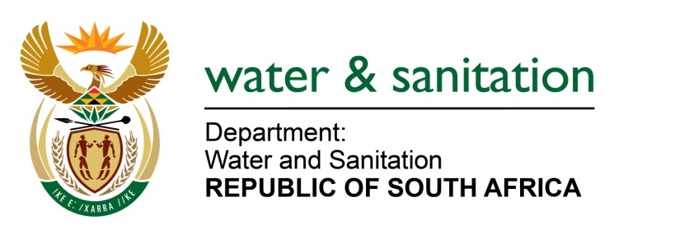

NATIONAL ASSEMBLY

FOR WRITTEN REPLY

QUESTION NO 290

DATE OF PUBLICATION IN INTERNAL QUESTION PAPER:
(INTERNAL QUESTION PAPER NO. 2) 17 FEBRUARY 2023

290. Ms S A Buthelezi (IFP) to ask the Minister of Water and Sanitation:
With regard to the water boards and the role that they will be playing in the reconfiguration and/or enhancement of service delivery, what (a) does his department intend to do about the water boards’ own internal challenges of not being able to conduct planned maintenance and/or pay creditors on time and (b) measures will his department put in place to ensure that planned maintenance still goes ahead and is not affected, considering the financial constraints of municipalities in paying for the provision of water?
NW302E
---00O00---

MINISTER OF WATER AND SANITATION

- To address governance challenges among Water Boards and enhance the role that these entities will be playing to enhance service delivery at local government level; the Department has reviewed the Water Boards in terms of financial sustainability, governance matters and extending services to areas that are not currently serviced. The review and reconfiguration of Water Boards is intended to achieve the following:
- Better economies of scale
- Enhance market capitalisation for infrastructure projects
- Increase water access to un-serviced rural areas
- Enable better cross-subsidisation and increased financial sustainability
- Facilitate differential service delivery levels and tariff modelling across the province
- Enable better working relationships with provincial governments - there has been a general effort to align water boards boundaries with provincial boundaries
- Enable Water Boards to better support Water Services Authorities (WSAs).

- It should also be noted that non-payment of Water Boards by municipalities threatens financial viability of Water Boards. To address this, the Department of Water and Sanitation in collaboration with National Treasury has put in place the following measures to strengthen billing and revenue collection and address the escalating debt of municipalities to water entities:
- The Department of Water and Sanitation (DWS) will collaborate with National Treasury to ensure that equitable share allocations are withheld from non-paying municipalities.
- DWS will ensure that standardised credit control and debt recovery processes is in place across all the water boards. This includes consistent enforcement of water limitations/restrictions on non-paying municipalities and legal processes to attach municipal bank accounts where necessary.
- Bulk prepaid meters will be installed by water boards in municipalities with a poor payment record.
- The Minister is further consulting the 144 Water Services Authorities on the outcome of the above-mentioned workshop.

---00O00---

