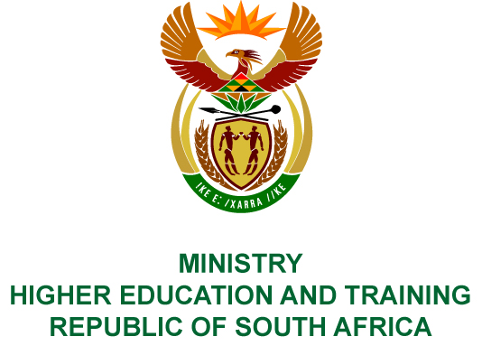
Private Bag X893, Pretoria, 0001, Tel (012) 312 5555, Fax (012) 323 5618
Private Bag X9192, Cape Town, 8000, Tel (021) 469 5150, Fax: (021) 465 7956
Memorandum from the Parliamentary Office
NATIONAL ASSEMBLY
FOR WRITTEN REPLY
QUESTION 29
DATE OF PUBLICATION OF INTERNAL QUESTION PAPER: 08/02/2018

(INTERNAL QUESTION PAPER NO 1 OF 2018)
Mr D America (DA) to ask the Minister of Higher Education and Training:
- With regard to the Cape Peninsula University of Technology (CPUT) and the ongoing protests taking place at the specified institution, (a) what is the total number of students who have been awarded funding by the National Student Financial Aid Scheme (NSFAS) but have not yet received their funding for 2017 and (b) of these students, what is the total number that has not received the funding due to (i) not having had Loan Agreement Forms (LAF) generated by NSFAS, (ii) not having signed the LAF that has been generated by NSFAS and/or (iii) another administrative error;
- did the student representative council transport students to the NSFAS offices to sign their LAFs in person due to an administrative error by NSFAS in the online process; if so, what steps has NSFAS taken to fix the problem;
- (a) what number of students have not received NSFAS allowances for food since 30 August 2017 and (b) what measures will her department take to urgently address the administrative failures of NSFAS?
NW33E

REPLY:
The National Student Financial Aid Scheme (NSFAS) has provided the following responses to the questions posed.
- (a) As at 15 December 2017, NSFAS reported that 7 713 students registered at the Cape Peninsula University of Technology (CPUT) had been awarded funding and 2 169 of these students had not received payments.
- (i) 52 Students’ LAFSOPs (Loan Agreement Forms and Schedule of Particulars) could not be generated by NSFAS due to course code mismatches between the data from the institution and NSFAS records on the system.
- 1 294 Students had not signed their LAFSOPs.
- 823 Students payments were being processed.
NSFAS is not aware of any student that has not received funding due to any other administration error.
- NSFAS is not aware if the SRC arranged transport to NSFAS offices. NSFAS arranged for their Servicing Team to visit the institution to assist students with signing their LAFSOPs in August and October 2017. Both attempts were not successful as the students were protesting at that time, and campuses were closed. NSFAS then generated paper-based LAFSOPs, which the Financial Aid Office at CPUT collected and contacted students individually to sign these agreements. Those that were signed were returned to NSFAS for processing.
- (a) 2 169 students as outlined above.
- The Department of Higher Education and Training met with the Executive Committee (EXCO) of Universities South Africa and NSFAS on
15 June 2017 to address the administration issues raised by students, SRC Presidents and Secretaries General to discuss the challenges experienced during the 2017 roll out of the new student centred model and NSFAS’ proposed 2018 implementation plan. A joint task team was established to address the 2017 challenges and plans for the 2018 application cycle. The task team has been meeting since 15 June 2017 and progress related to the 2017 and 2018 processes is being closely monitored. In addition, NSFAS has deployed servicing teams to institutions where additional on-site support has been required.

