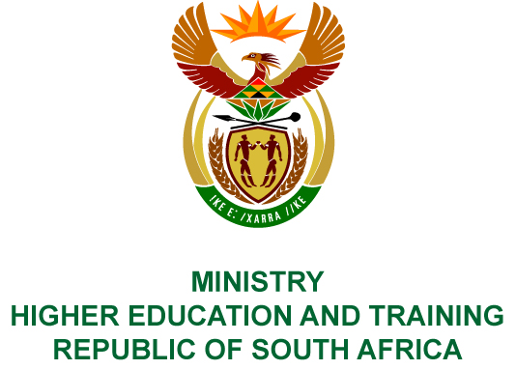
Private Bag X893, Pretoria, 0001, Tel (012) 312 5555, Fax (012) 323 5618
Private Bag X9192, Cape Town, 8000, Tel (021) 469 5150, Fax: (021) 465 7956
Memorandum from the Parliamentary Office
NATIONAL ASSEMBLY
FOR WRITTEN REPLY
QUESTION 2893
DATE OF PUBLICATION OF INTERNAL QUESTION PAPER: 12/10/2018
(INTERNAL QUESTION PAPER NO 32 OF 2018)
Ms N Nolutshungu (EFF) to ask the Minister of Higher Education and Training:
- What number of institutions of higher learning in the country have contracts with a certain company (name furnished) as at 9 October 2018 and (b) what (i) is the (aa) value and (bb) length of the contract in each case and (ii) are the relevant details of the goods and services that the specified company provides in each case?
NW3201E

REPLY:
- Seven (7) universities have confirmed that they have contracts with South Point while fifteen (15) universities have no contracts with the company. Four (4) universities, i.e. University of Cape Town, University of Fort Hare, University of KwaZulu-Natal and Vaal University of Technology did not respond.
- The details related to each confirmed contract, as provided by the institutions, are indicated in the table below:
Name of University | - (i) (aa) Value of the contract | (bb) Length of the contract | (ii) Goods and services provided
Cape Peninsula University of Technology | R45 729 920  (4 separate contracts for 4 residences) | 1 February 2018 to  30 November 2018 | Student accommodation for 1 535 students
University of Johannesburg | R13 942 442 for 2018  The amount (value) per annum will depend on the number of NSFAS qualifying students staying in the property in a particular year. | 1 January 2018 to  31 October 2020 | Student accommodation for NSFAS recipients
Mangosuthu University | Value of the three-year contract R51 734 664 (R1 437 074 per month) | Three-year contract ending in December 2020 | Student accommodation
Nelson Mandela University | R12 906 625 for 2018 | The length of the contract is one year subject to renewal if the company complies with the minimum accreditation requirements. | Student accommodation consisting of 607 beds, with a study area, kitchenettes, recreational areas, IT facilities, security and cleaning of common areas.
Sefako Makgatho University | R26 485 400 for 2018  (R2 207 200 per month) | 1 January 2011 to  31 December 2018 | Student accommodation for 992 students
University of Western Cape | R7 257 000  (R2 950 monthly rental per student) | 01 February 2018 to  31 November 2018 | Student accommodation for 248 students
University of the Witwatersrand | R 2 700 000 for six months | 1 July 2018 to 30 November 2018 | Emergency student accommodation for 270 students

