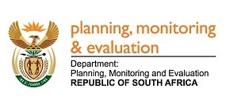
2891. Mr H B Groenewald (DA) to ask the Minister in The Presidency:
What is the detailed breakdown of and valuation for current and non-current assets and investments held by (i) his department and (ii) each entity reporting to him according to (aa) listed assets (aaa) directly held and (bbb) indirectly held and (bb) unlisted investments (aaa) directly held and (bbb) indirectly held by each of the entities, in each case breaking the current assets and investments down by 0-3 months, 3-6 months, 6-12 months and beyond 12 months? NW 3198E

REPLY:
The Department of Planning, Monitoring and Evaluation does not hold any investments. The current and non-current assets are mainly cash, prepayments, advances and debt. The Member should refer to the department’s audited 2016/17 annual financial statements as most of this information is contained therein.
Statistics South Africa current and non-current assets consist of unauthorised expenditure, cash and cash equivalents, prepayments, advances and receivables. The department does not hold any direct or indirect investments. The Member should refer to the department’s audited 2016/17 annual financial statements as most of this information is contained therein.

Approved / Not Approved

Mr J T Radebe, MP
Minister in The Presidency
Date:

