MINI ST R Y
STATE SEC U R I T Y
R E P U BL I C O F S OU T H A FR I CA

Po Box 5j27s, Waierftont, 8002, CAPE TOwN, 18th nor, 120 Plein Street, Parliament, CAPE TO\IN Te!. (021) *01 1800 tax. (011) 461 4
PO Box 1037, Meniyn. 0077. PRETORiA, Rub First Budding, 8o0a‹e. Cnr Merbuiy Road 6 Lo's Avenue, MENLYI'J Tel: (OU) 367 0700 Fex: f012) R7 0749

NATIONAL ASSEMBLY QUESTION FOR WRITTEN REPLY QUESTION NO: 289
Mrs T G Mpambo-Sibhukwana (DA) to as the Minister of State Security:
What (a) total amount is budgeted for the private office for the 2019-2020 financial year and (b) was the (i) total remuneration, (ii) salary level , job title, (iv) qualification and (v) job description of each employee appointed in her private office since 1 May 2019?
REPLY:

- The total amount budgeted for the Ministry for the 2019-2020 financial year is R 47 081 363.09.
- It should be observed that the SSA may be held accountable on such matters by the Joint Standing Committee on Intelligence (JSCI), the Inspector-General and the Auditor-General.

Approved/Not Approved
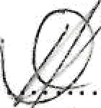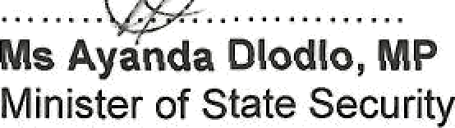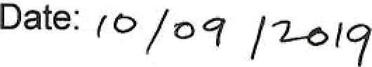

Reply to the Parliamentary Question 289 to the Minister of State Security

