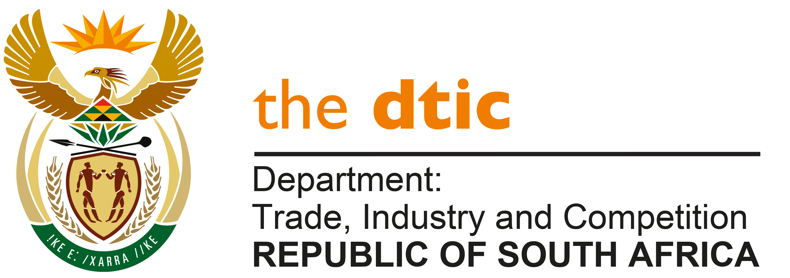

THE NATIONAL ASSEMBLY

QUESTION FOR WRITTEN REPLY

QUESTION NO. 2888

DATE PUBLISHED: 9 SEPTEMBER 2022

Mr M J Cuthbert (DA) to ask the Minister of Trade, Industry and Competition:

(1) What total amount has been invested in the foundry and/or mini-mill industry by the Industrial Development Corporation (IDC) since 2010,

(2) will he furnish Mr M J Cuthbert with an itemised list for each (a) year and (b) individual investment;

(3) what is the debt to equity proportions for each investment;

(2) what amount has been written off in the same period (a) for each investment and (b) in total? NW3089E

Reply

The IDC has approved R14,4 billion of funding in the Foundry and/or mini mill industry since FY 2010, in the following forms: industrial loans of R5,99 billion, equity of R8,44 billion and grants of R4m.

In addition, the IDC provided guarantees of R5,5 billion to companies in the sector.

A supplementary reply will be submitted shortly, with additional information.

-END-

