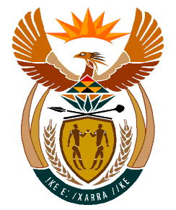

MINISTRY:
HUMAN SETTLEMENTS, WATER AND SANITATION
REPUBLIC OF SOUTH AFRICA

NATIONAL ASSEMBLY

QUESTION FOR WRITTEN REPLY

QUESTION NO.: 288

DATE OF PUBLICATION: 6 MARCH 2020

Dr S S Thembekwayo (EFF) to ask the Minister of Human Settlements, Water and Sanitation:
Whether her department has any plans in place to build Reconstruction and Development Programme houses in Kakati, Ward 17 in Mpumalanga; if not, what is the position in this regard; if so, (a) by what date and (b) what are the relevant details? NW442E

REPLY:
(a)&(b)According to the information received from the Msukaligwa Local Municipality, plans are already in place to build houses in Kakati, Ward 17 for the 2020/21 financial year. The quantity of houses to be constructed will be informed by the number qualifying beneficiaries and available resources.

In addition, projects that are currently being implemented in Kakati Ward 17 include the upgrading of Mavundla Street (80% complete), Motau and Tutu Streets (98.5% complete).

