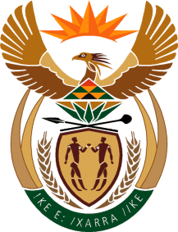

MINISTRY OF TOURISM
REPUBLIC OF SOUTH AFRICA

Private Bag X424, Pretoria, 0001, South Africa. Tel. (+27 12) 444 6780, Fax (+27 12) 444 7027
Private Bag X9154, Cape Town, 8000, South Africa. Tel. (+27 21) 469 5800, Fax: (+27 21) 465 3216

NATIONAL ASSEMBLY:

QUESTION FOR WRITTEN REPLY:
Question Number: 288
Date of Publication: 15 February 2019
NA IQP Number: 2
Date of reply: 5 March 2019

Mr T Rawula (EFF) to ask the Minister of Tourism:

What number of (a) tender briefings were held in 2018 by (i) his department and (ii) each of the entities reporting to him and (b) the specified briefings were compulsory? NW302E

Reply:
Institution | (a)What number of tender Briefings held in 2018 | (b) What number of the specific briefings were compulsory
(i)Department | Seven | Seven
(ii)Entity – South Africa Tourism | One | One

