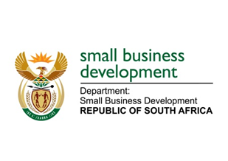
NATIONAL ASSEMBLY

QUESTION FOR WRITTEN REPLY

“287. Adv T E Mulaudzi (EFF) to ask the Minister of Small Business Development:

What number of (a) tender briefings were held in 2018 by (i) her department and (ii) each of the entities reporting to her and (b) the specified briefings were compulsory?
NW300E

REPLY:

(a)(i)&(b)The Department of Small Business Development (DSBD)
(a)(i) The DSBD did not advertise any tenders for the 2018/2019 and therefore no briefing sessions were held
(b) The Department did not have any briefing session and it must be noted that briefing session can no longer be made compulsory but rather suppliers would be encouraged to attend the briefing session.

(a)(ii)&(b) The Small Enterprise Development Agency (Seda)
No | Tender Number | Description | Compulsory / Non-compulsory
1. | RFP/T 01-2018/19 | Invitation to tender for provision of Security Services at Seda National Office for eighteen (18) months period. | Compulsory
2. | RFP/T 06-2018/19 | Invitation to tender for Rental Office Space for Seda’s JTG Northern Cape Branch Office in Kuruman for a period of three (3) and five (5) years | Compulsory
3. | RFP/T 08-2018/19 | Appointment of a Service Provider to provide an Internal Audit Services on a co-sourced basis for a period of three (3) years | Compulsory

(a)(ii)&(b) The Small Enterprise Finance Agency (sefa)
No | Tender Number | Description | Compulsory / Non-compulsory
1. | Sefa: 19/DSBD/2018 | Appointment of Service Provider to conduct the 2018 Annual Review on SMME and Co-operatives in South Africa (DSBD) | Non-compulsory
2. | Sefa: 11/FIN/2017 | Appointment of Service Provider for Construction Work to reinstate the 1st floor shops and roof refurbishing at the Victoria Street Market located at 151/155 Bertha Mkhize Road, Durban, KZN | Compulsory
3. | Sefa: 17/FIN/2017 | Appointment of a Service Provider for Public Sector Invoice Discounting | Compulsory

