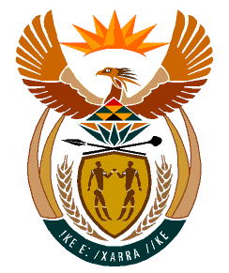

MINISTRY
HUMAN SETTLEMENTS
REPUBLIC OF SOUTH AFRICA

Private Bag X645, Pretoria, 0001. Tel: (012) 421 1309, Fax: (012) 341 8513

Private Bag X9029, Cape Town, 8000. Tel (021) 466 7603, Fax: (021) 466 3610

NATIONAL ASSEMBLY
QUESTION FOR WRITTEN REPLY
QUESTION NUMBER: PQ 2865 [NW 3465E.]

DATE OF PUBLICATION: 2 SEPTEMBER 2022

2865. Mrs. M R Mohlala (EFF) ask the Minister of Human Settlements:
What are the (a) full details of the progress with regard to the R255 million Free State asbestos corruption case and (b) reasons that it has taken so long to arrest the former Head of the Gauteng Department of Human Settlements, Ms. Ann Diedricks? NW3465E

Reply

- The Free State Provincial Department of Human Settlements indicated that 13 accused have been charged by the State and are going to appear in the Bloemfontein High Court on the 23rd of September 2022. Amongst the individuals charged are the following: former HOD of the Department and three current employees namely the Chief Financial Officer, Chief Director responsible for Project Management and the Director responsible for Supply Chain Management.

- The Gauteng Provincial Department of Human Settlements did not open a criminal case against the former Acting Head of the Gauteng Department of Human Settlements. The appropriate organ of state to respond to this Question is the Free State Directorate of Priority Crimes Investigation (DPCI) which is investigating the matter.

