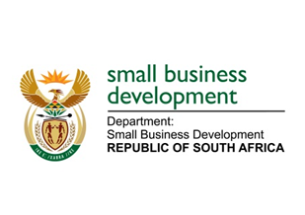
NATIONAL ASSEMBLY

QUESTION 286 FOR WRITTEN REPLY

“286. Mr. B B Nodada (DA) to ask the Minister of Small Business Development:

What (a) total amount is budgeted for her private office for the 2019-20 financial year and (b) was the (i) total remuneration, (ii) salary level, (iii) job title, (iv) qualification and (v) job description of each employee appointed in her private office since 1 May 2019?”

NW1252E
REPLY:
The Guide for Members of the Executive give guidance on the appointment of the staff in the Private Office. It equally provides the recommended salary levels of each post. The salary levels are adjusted on an annual basis as prescribed in the Public Service Regulations.

The Office of the Minister has a staff complement as defined in the Guide for Members of the Executive. In line with the Protection of Personal Information Act (PoPi) and the Basic Conditions of Employment Act, I am unable to provide the members with such confidential information in the manner it is requested.

I however draw the honourable members to the Department’s Annual Report wherein the organogram of the Department provides the information required. Should it be insufficient, the Department will make the personal files of the officials available for further scrutiny by the Auditor General as prescribed by the Act.

- Total amount budgeted for the private office for both the Minister and the Deputy Minister is
R 15, 844,624.00

- (i) (ii) (iii) Ministry- the Minister’s office staff
- One employee at salary level 14
- Three employees at salary level 13
- Two employees at salary level 11
- One employees at salary level 7
- Two employees at salary level 3
- One employee at salary level 5

- Deputy Minister’s office staff
• One employee at salary level 13
• One employee at salary level 12
• One employee at salary level 11
• One employees at salary level 11
- One employee at salary level 3

_______________________________________________________________________________

