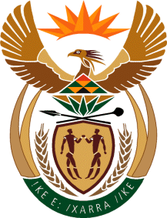

MINISTRY: COMMUNICATIONS
REPUBLIC OF SOUTH AFRICA
Private Bag X 745, Pretoria, 0001, Tel: +27 12 473 0164 Fax: +27 12 473 0585
Tshedimosetso House,1035 Francis Baard Street, Tshedimosetso House, Pretoria, 1000

NATIONAL ASSEMBLY
QUESTION FOR WRITTEN REPLY
QUESTION NUMBER: 2858 of 2015
DATE OF PUBLICATION: 07 AUGUST 2015

Mr T R Majola (DA) to ask the Minister of Communications:

With reference to her reply to question 2503 on 29 July 2015, in which she stated that a total amount of R167 872, 72 was spent by her department on international flights whilst in Annexure 1 no reference is made to any international flights, (a) how many international flights has she undertaken since her appointment up to 3 August 2015 and (b) in each case, what (i) were the destinations, (ii) airlines were used and (iii) class did she fly? NW3331E
___________________________________________________________________REPLY: MINISTER OF COMMUNICATIONS
- Minister had undertaken 6 international trips since Minister’s appointment until 3 August 2015.

(i) London, Gaborone, Swaziland, Mozambique, USA and China

(ii) South African Airways

(iii) 2 economy and 4 business class flights

MR NN MUNZHELELE
DIRECTOR GENERAL [ACTING]
DEPARTMENT OF COMMUNICATIONS
DATE:

MS AF MUTHAMBI (MP)
MINISTER OF COMMUNICATIONS
DATE

