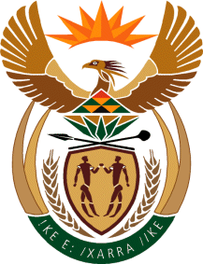

MINISTRY: COMMUNICATIONS
REPUBLIC OF SOUTH AFRICA
Private Bag X 745, Pretoria, 0001, Tel: +27 12 473 0164 Fax: +27 12 473 0585
Tshedimosetso House,1035 Francis Baard Street, Tshedimosetso House, Pretoria, 1000

NATIONAL ASSEMBLY
QUESTION FOR WRITTEN REPLY
QUESTION NUMBER: 2856 of 2015
DATE OF PUBLICATION: 07 AUGUST 2015
Mr G R Davis (DA) to ask the Minister of Communications:
Did her department set up an SABC Task Team; if so, (a) who did the task team comprise, (b) what is the mandate of the task team, (c) on what date was the task team set up, (d) what amount did her department spend on the specified task team and (e) what were the findings of the task team? NW3329E

REPLY: MINISTER OF COMMUNICATIONS
The department did not set up a SABC Task Team.

MR NN MUNZHELELE
DIRECTOR GENERAL [ACTING]
DEPARTMENT OF COMMUNICATIONS
DATE:

MS AF MUTHAMBI (MP)
MINISTER OF COMMUNICATIONS
DATE

