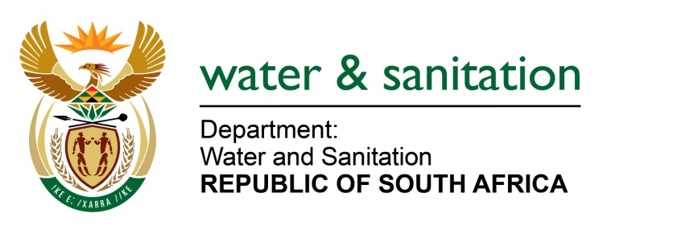

NATIONAL ASSEMBLY

FOR WRITTEN REPLY

QUESTION NO 2851

DATE OF PUBLICATION IN INTERNAL QUESTION PAPER: 15 SEPTEMBER 2017
(INTERNAL QUESTION PAPER NO. 33)
2851. Ms T E Baker (DA) to ask the Minister of Water and Sanitation:
Has she authorised a certain company (name furnished) to undertake listed water use despite the suspension of its water use licence as a result of an appeal in respect of that licence pending before the Water Tribunal; if not, what enforcement action is her department taking to stop the specified company from undertaking the listed water use it has announced; if so, what are the relevant details? NW3158E

---00O00---
REPLY:

(a) No, the Minister has not authorised Kropz Elandsfontein (Pty) Ltd formerly Elandsfontein Exploration and Mining (Pty) Ltd to undertake listed water use despite the suspension of its water use licence as a result of an appeal in respect of that licence pending before the Water Tribunal.
(b) The Compliance Monitoring and Enforcement team of my department conducted an inspection on the 06 September 2017 at Portion 4 of farm Elandsfontein 349, Malmesbury Rd which is a property of Kropz Elandsfontein (Pty) Ltd formerly Elandsfontein Exploration and Mining (Pty) Ltd in respect of which a water use licence that was issued by my department. The finding of this inspection is that there was no water use taking place in the said property in violation of water use licence suspension
---00O00---

