36/1/4/1(2018)
NATIONAL ASSEMBLY

FOR WRITTEN REPLY QUESTION 2844

DATE OF P.UBLICATION IN INTERNAL QUESTION PA ER: 12 OCTOBER 2018 (INTERNAL QUESTION PAPER MO 32-20181
2844. Mr D W Macpherson (DA) to ask the IVlinister of Police:

What total number of cases that were reported at the Umhlali Pollce Station of (a) murder, (b) attempted murder, (c) rape, (d) house breaking, (e) hijacking, (fl theft of motor vehicles and (g) house robbery resulted in convictions in the 2017-18 financial year?
NW3140E

REPLY:

The following number of convictions were recorded at Umhlali Police Statlon In the 2017/2018 flnancial year:

a. Murder
Offence

Total convictions 6

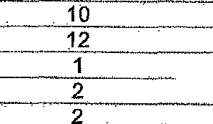
b . Attem ted murder _ 5
{c/ Rap
d House breakln Residential & Buslnasses} _ e HI ackin V hic es T u ks
Theft of motor vehicles & motor c cles

DI

Date:

SIKI
LIEUTENANT GENERAL
MMtSSIONER: DETECTIVE SERVICE

\ O I O

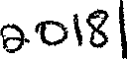
Reply to question 2844 recommend.ed / not

. LIEUTENANT GENERAL DE NATIONAL COMMISSIONER: CRIME DETECTION M YS ANE

FOR WRITTEN REPLY

QUESTION 2844

DATE OF PUBLICATION.fN fNTER A_QUESTION.PAPER: 12 OCTOBER 2018
{INTERNAL QUESTION PAPER NO 32-2018)

Reply to questlon 2844 recommended /

GENERAL
CO
LE (SOEG)
NERC
TH AFRICAN POLICE SERVICE

Date:

Reply to question 2844 approved /

MINISTE OF POLICE BH CELE, MP

