58/1/4/1(2021)
NATIONAL ASSEMBLY

LI
ODE

2842. Mr A C Roos (DA) to ask the Minister of Police:

Whether he will provide Mr A C Roos with a list of the number of vehicles (a)(i) allocated to (aa) support services, (bb) visible policing, (cc) rural safety and (dd) detectives and (ii) boarded in total for each police station in Gauteng and (b) for each of these categories what number is (i) operational and (ii) out of service?
NW3362E
REPLY:

(a)(i)(aa)(bb)(cc)(dd)(ii)(b)(i) and (ii)
The number of vehicles, allocated to support services, visible pollcing, rural safety and detectives, the number of vehicles, boarded in total for each police station in Gauteng and the number of vehicles, operational and out of service, is attached, as per annexure A.

Reply to question 2842 recommended/

LE (SOEG)

Datu: *' " " ''
GENERAL
NER! TH AFRICAN POLICE SERVICE

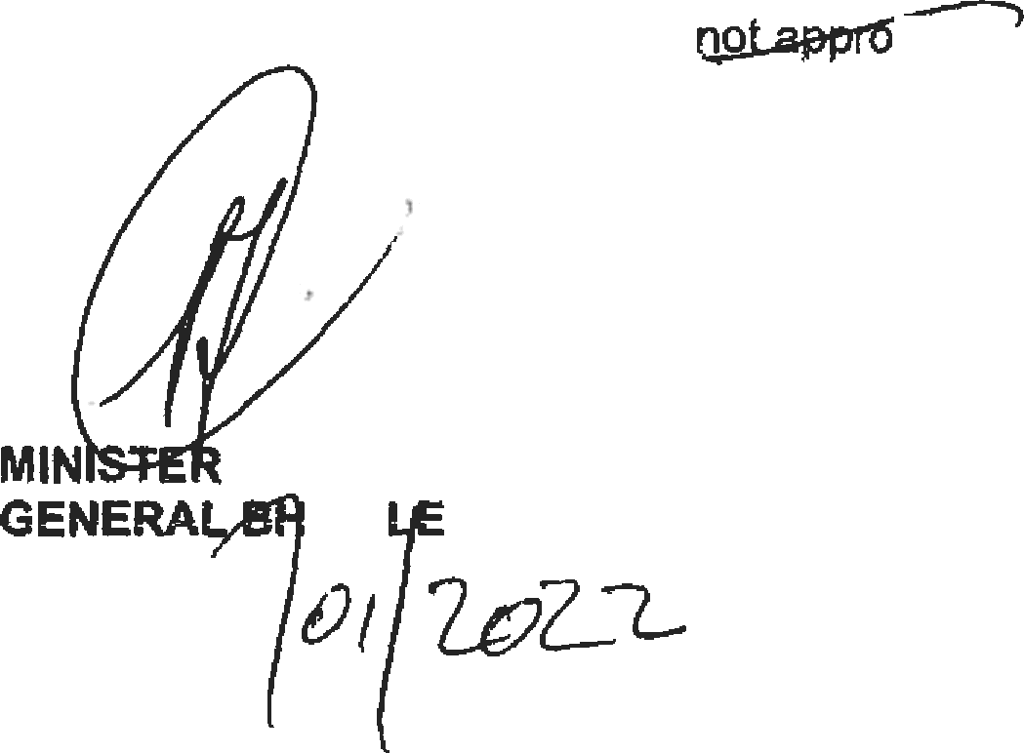
Reply to question 2842 approved/
ved
OF POLICE
CE , T4P
Date:

Police Station
t>)(i)(aa) Support
(a)(i)(bb) Visible
(a)(i)(dd) Detective

Totsl number

(a)(ii) Vehicles

Visible Policlng
(b)(ii)
Detective Service
(b)(ii)
Support Service

(b)(ii)

Brixton Bronkhorstsgruit
_ Brooldyn Carletonville
Service
Actual Vehicles
Adonville |  | 4 |  |  | 18 |  | 10 | 38 |  | 2 |  |  | 17 |  | _ |  | 1 |  | 16 |  |  | 0 |  | 3 | 1
Akasia |  | 4 |  |  | 21 |  | 19 | 44 |  | 8 | _ |  | 13 |  |  |  | 8 |  | 12 |  |  | 7 |  | 4 | 0
Alberton |  | 4 |  |  | 20 |  | 19 | 43 |  | 9 |  |  | 16 |  |  |  | 4 |  | 14 | | |  | 5 |  | 4 | 0 _
Alexandra |  | 6 |  |  | 34 |  | 23 | 63 |  | 1 |  |  | 29 |  | ( |  | 5 |  | 18 |  |  | 5 |  | 4 | ) 2
Aseridfieville 4 _ 18 22 44 7 16 2 17 5
Bedfordview 3 16 15 34 4 13 [ 3 3
Bekkersdal |  | 1 |  |  | 20 |  | _ 11 _ | 32 |  | 4 |  |  | 17 |  | 3_ |  |  |  | 8 | 3
Benoni |  | 10 |  |  | 33 |  | 26 | 71 |  | 8 |  |  | 20 |  | 12 |  |  |  | 26 | 2
Boipatong |  | _ |  | 6 | 13 |  | 8 |  | 27 | 4 |  |  |  | 11 |  | 2 |  |  | 6 |  |  | 2
Boksburg |  |  |  | 4 | 22 |  | 17 |  | 43 | 2 |  |  |  | 20 |  | 2 |  |  | 13 |  | ) | 4 |  | 3 | ) 1
Boksburg North |  |  |  | 6 | 19 |  |  |  | 45 | 8 |  |  |  | 16 |  | 3 |  |  | 15 |  | 1 | 5 |  | 4 | . 2
Booyssns |  |  |  | 4 | 27 |  | 28 |  | 50 |  |  |  |  | 21 |  | 6 |  |  | 22 |  |  | 6
Boschkop_ |  |  |  | 3 | 12 |  | 9 |  | 24 |  |  |  |  | 11 |  | 1 |  |  | 7 |  |  | 2
Brackendowns |  |  |  | 3 | 20 |  | 11 |  | 34 |  |  |  | _ | 17 | _ | 3 |  | _ | 10 |  |  | 1
Brakpan | _ |  |  | 8 | 24 |  | 22 |  | 54 |  |  |  |  | 22 |  | _2 |  |  | 20 | _ |  | 2
Bramley |  |  |  | 4 | 16 |  | 10 |  | 30 |  |  |  |  | 13 |  | 3 |  |  | 5 |  |  | 5

 | 20 |  | 17 |  | 38 | 7 | 10 | 6 | 4
5 | 16 | _ | 28 |  | 49 | 9 _ |  |  | 5 | 0

Z

Policing
Actual Vah es_

19
Service
AcNaI Vehicles

18
of vehicles

39
Recommended for Boarding

5
(+)(1
Operational
Out of
Operational

15

Out of

4
(b)(i)
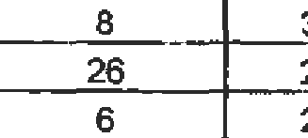Operational

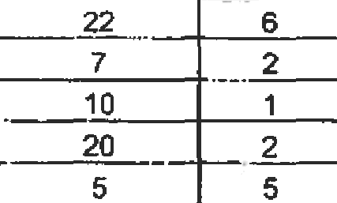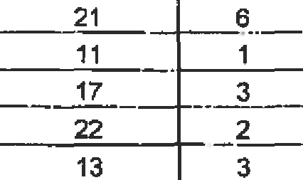 3

2
Out of

0

Cleveland Crystalpark C‹JIinan Daveyton
4 14 16 34 3
2 16 9 27 5
1 11 11 23 2
4 19 17 40 3
11 1 3
10 ] 6
11 0
19 0
14 ]“ 2
8 | 1
10 1 1

15 1 2
4 ) 0
z 1 a
1 0

Dawn Park _ _ 2 17 _ 11 30 5 12 8
De Deur | 3 | 20 | 16 |  | 39 | 4 | 11 | 10 | 14
Devon _ | 1 | 11 | 4 |  | 16 | 7 |  |  | 4 |  | 0 | 1
Diepldoof | 7 | 19 | 14 |  | 40 | 3 | 19“ | 0 | 4o |  | 4 | 6
Diepsloot | 6 | 26 | 21 |  | 53 | 3 | 21 | 5 | 18 | } | 3 | 4 |  | 2
Dobsonville | 5 | 26 | 23 |  | 54 | 6 | 20 | 6 | 19 | ) | 4 | 4 | I | 1
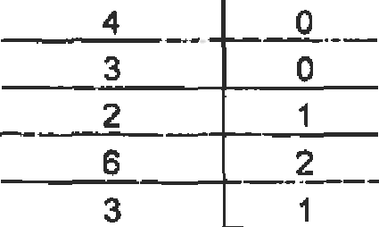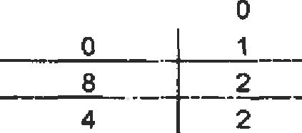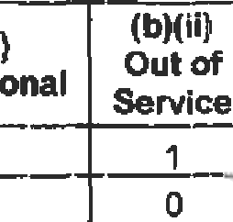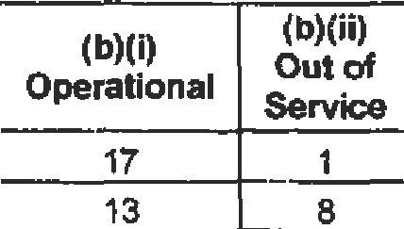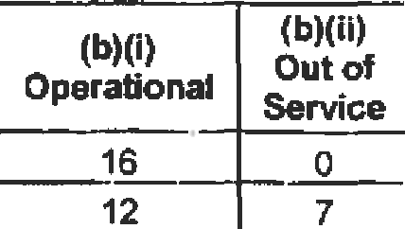1

Police Station

falfiIf•*t
Support

‹•›f'if*bT
Viaible

taIt'›t T
Detecthze

Total number

(a)(ii) Vehicles

ViSlbtB @OliCing

(b)(it)

(g)(j)

- {ii)

Service
Actual
 | Vehicles | Vehicles |  | Vehicles | vahiCles | for Boarding | Oj:›erational | Service |  | Operational |  | sewlce | Operational | Service
Doornkop | 2 | 15 |  | 7 | 24 | 3 | 10 | 5 |  | 5 |  | 2 | 1 | 1
Dou£Llasdale | 6 | 24 |  | 26 | 56 | 6 | 22 | 2 |  | 20 |  | 6 | 4 | 2
Dube | 2 | 13 |  | 6 | 2f | 3 | 11 | 2 |  | 5 |  | 1 | 1 | 1
Duduza | 2 | 19 |  | 12 | 33 | 5 | 16 | 3 |  | 9 |  | 3 | 2 | 0
Dunnottar | 1 | 12 |  | 4 | 17 | 0 | 9 | 3 | _ | 2 |  | 2 | 1 | _
Edengark | 3 | 15 |  | 12 | 30 | 6 | 15 | 0 |  | 10 |  | 2 | 2 | 1
Edenvale | 3 | 15 | _ | 15 | 33 | 8 | 14 | 1 |  | 13 | _ | 2 | 3 | '3
Eersterust | 2 | 11 |  | 7 | 20 | 2 | 9 | 2 |  | 5 |  | 2 | 1 | 1
Ekangala | 1 | 15 |  |  | 23 |  | 9 | 6 |  | 7 |  | 7 | 2 | 0

Policing
Actual
Service
Actual
of Recommended
(b)(I)
Out of
(b}(i)
Out of
Out of

Eldorado Park 7 | 29 | 29 |  |  | 65 |  |  |  | 21 | 8 | 20 | 9 | 5 |  | "2
sburq 4 | 18 | J3 |  |  | 35 | _ | 4 |  | 14 | 4 | 11_ | 2
_ Ennerdale 4 | 14 | 13 |  |  | 31 |  | 1 |  | 11 | 3 | 7 | C |  |  | 1 _’

Erasmia | 1 |  | 12 | 12 | 25 |  | 3 | 11 |  | 1 |  | 9 |  |  | 3 | 1 | 0
Etwatwa | 3 |  | 17 | 18 | 38 |  | 4 | 12 |  | 5_ |  | 15 |  |  | 3 | 3
Evaton | 5 |  | 25 | 30 | 60 |  | 13 | 23 |  | ? |  | 23 |  |  | 7 | 3 | 2
Fairland | 1 |  | 12 | 7 | 20 |  | 1 | 11 |  | 1 |  | 6 |  |  | 1 | 1 | 0
Florida | 5 |  | 13 | 25 | 43 |  | 4 | 1‹ |  | 2 |  | 1e |  |  | 6 | z | z
Fochville | 1 |  | 15 | 7 | 23 |  | 3 | 12 |  | 3 |  | 5 |  |  | 2 | 1 | 0
Ga Rankuwa | 6 |  | 23 | 17 | 46 |  | 8 | 21 |  | 2 |  | 13 |  |  | 4 | 6 | 0
Garsfontein | 2 |  | 21 | 15 | 38 |  | 3 | 18 |  | 3 |  | 11 |  |  | 4 | 2 | 0
_Germiston | 12 |  | 24 | 30 | 66 |  | 11 | _, 20 _ | _ | 4 |  | 22 |  |  | 8 | 11 | 1
Hammanskraal | 3 |  | 19 | 11 | 33 |  | 7 | 18 |  | 1 |  | 10 |  |  | 1 | 3 | 0
„Heidelberg Gg | 2 |  | 18 | 12 | 32 |  | 4 | 15 |  | 3 |  | 10 | _ |  | 2 | 2 | 0
Hekpoort | 2 |  | 13 | 4 | 19 |  | 2 | 8 |  | 5 |  | 2 |  |  | 2 | 2 | 0
Hercules | 2 |  | 15 | 13 | 30 |  | 4 | 11 |  | 4 |  | 12 |  |  | 1 | 2 | 0
Hillbrow | 6 |  | 32 | 37 | 75 |  | 3 | 30 |  | 2 |  | 33 |  |  | 4 | 6 | 0
Honeydew _ | 13 |  | 54 | 42 | 109 |  | 5 | 48 |  | 6 |  | 34 |  | _ | 8_ | 12 | 1
lvory Park | 4 |  | 37 | 36 | 77 |  | 4 | 28 |  | 9 |  | 31 |  |  | 5 | 4 | 0
Jabulani _ | 4 |  | 24 | 17 | 45 |  |  | 22 |  | 2 |  | 12 |  |  | 5 | 3 | 1
JepjDe | 4 | “ | 25 | 31 | 60 |  |  | 23 |  | 2 | ” | 22 |  |  | e |  | a

Police Station |  | (a}(i)(aa) Support Service  Actual Vehicles |  | (a)(i)(bb) Visible Policing  Actual Vehicles |  | (a)(i)(dd) Detective Service  Actual Vehicles | Total number of vehicles | (a)(ii) Vehicles  Recommended for Boarding |  |  |  | Visible Policing |  | Detective Service
 |  |  |  |  |  |  |  |  |  |  |  | (b)(i) Operational | (b)(ii Out of Service | (b)(i) Operational |  |  | Out of  Servioe | Operational |  |  | (bb)(1lI1}  Out of  Service
Jhb Central |  | 14 |  | 3g |  | s6 | 109 | 6 |  |  |  | 38 | 1 | 50 |  |  | 6 | (0
Kagiso |  | 7 |  | 31 |  | 30 | 68 | 2 |  |  |  | 22 | 9 | 26 |  |  | 4
Kameeldrift Katlehong _ |  | 2  10 |  | 11  27 |  | 7 _  20 | 20  57 | 1  12 |  |  |  | 8  20 | 3  7 | 6  16 |  |  | 1  4 |  |  |  | 0....  4
Katlehonn North |  | 3 |  | 22 |  | 16 | 41 | 6 |  |  |  | 16 | 6 | 15 |  |  | 1 |  |  |  | 0
Kempton Park |  | 7 |  | 30 |  | 52 | 69 | 5 |  |  |  | 25 | 5 | 23 |  |  | 9 | 7
Khutsong |  | 2 |  | 18 |  | 10 | 30 | 1 |  |  |  | 14 | 4 | 10 |  |  | 0 |  | 2 |  | _ 0
Kliorivier |  | 2 |  | 16 |  | 7 | 25 | 6 |  |  |  | 12 | 4 | 7 |  |  |  | 2 |  |  | 0
Kliptowri |  | 4 |  | 21 |  | 22 | 47 | 3 |  |  |  | 14 | 7 | 13 |  |  |  |  |  |  | a | _ _
Krugersdorp |  | 9 |  | 34 |  | 27 | 70 | 6 |  |  |  | 22 | 12 |  | 20 | _ |  |  |  |  | 1
Kwa Thema |  | _ | 3 | 20 |  | 17 | 40 | 7 |  |  |  | 18 | 2 | 1*, |  |  |  |  | 3 | ,_ | 4
Langtaagte |  | 1 |  | 14 |  | 13 | 28 |  | 4 | _ |  | 8 | 6 " | 11 |  |  | 2 | 1 |  |  | 0
Laudium |  | 2 |  | 10 |  | 7 | 19 | 2 |  |  |  | 10 | 0 | 7 |  |  | 0 | 1 |  |  | 1 | _ _
Lenasia |  | 4 |  | 17 |  | 18 | 39 | 1 |  |  |  | 14 | 3 | 15 |  |  | 3 | 4 |  |  | 0
Lenasia South |  | 5 |  | 19 |  | 11 | 35 |  | 3 |  | _ | e | 1o | 7 |  |  | 4 | 3 |  |  | 2
Linden |  | 3 _ |  | 20 |  | 23 | _ 46 | 1 |  |  |  | 15 | 5 | 21 |  |  | 2 | 2 |  |  | 1
Loate |  | 3 |  | 13 |  | 19 | 35 |  | 7 | _ |  | 11 | 2 | 15 |  |  |  |  |  |  | 2
Lyttelton |  | 5 |  | 23 | _ | 21 | 49 | 7 |  |  |  | 20 | 3 | 16 |  |  |  |  |  |  | 0
Maboj›ane |  | 3 |  | 18 |  | 13 | 34 | 3 |  |  |  | 15 | 3 | 10 |  |  |  |  |  |  | 0
Magaliesburg |  | 4 |  | 12 |  | 3 | 19 | 3 |  |  |  | 10 | 2 | 3 |  |  | 0 |  |  |  | 0 |  |  | _
Mamelodi | _ | 13 |  | _18 |  | 19 | 50 _ | 5 |  |  |  | 13 | 5 | 16 |  |  | _ | 10 |  |  | 3
Mamelodi East |  | 4 |  | 29 |  | 27 | 60 | 7 |  |  |  | 22 | 7 | 22 |  |  | 5 |  |  |  | 1
Meadowlands |  | 6 |  | 21 |  | 23 | 50 | 3 |  |  |  | 16 | 5 | 20 |  |  | 3 |  | s | _ | 1
Meyerton |  | 3 |  | 20 |  | 14 | 37 | 9 |  |  |  | 15 | 5 | 12 |  |  | 2 |  |  |  | 0
Midland |  | 4 |  | 31 |  | 31 | 66 | 2 |  |  |  | 25 | 6 | 28 |  |  | 3 |  |  |  | 1 |  | _
Moffatview |  | 2 |  | 16 |  | 20 | 38 | 6 |  |  |  | 16 | 0 | _ | 19 |  | 1 | 2 |  |  | 0
Mondeor |  | 2 |  | 21 |  | 21 | 44 | _ | 2 |  |  | 17 | 4 | 12 |  |  | 9 | _ | 2
Moroka |  | 8 |  | 36 |  | 33 | 77 | 4 |  |  |  | 27 | 9 | 27 |  |  | 6 | 8 |  |  | 0
Muldersdrift |  | 2 |  | 16 |  | 7 | 25 | 3 |  |  |  | 11 | 5 | 6 |  |  | 1 | 2
Naledi |  | 4 |  | 13 |  | 15 | 32 | 2 |  |  |  | 8 | 5 | 13 |  |  | 2 | 3 |  |  | 1

3

Police Station
ta›‹i ‹-›
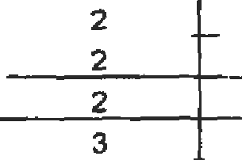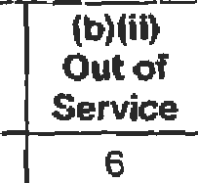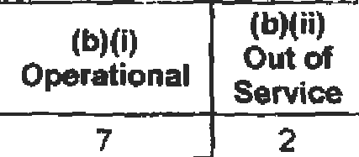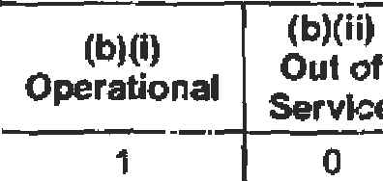Support

(aT8Ttb*\
Visible

\»\0‹<<›
Detective

Total number

  - {ii) Vehicles

Visible Policing

\il)“

oetacttve Service

(b)(li}

Service
Actual Vehicles
Policing
Actual Vehicles
Service
Actual Vehicles
p
vehicles
mmgycl
for Baarding
(b)(i)
Pest nal
Out of Service
(b)(I)
Operational
t>Tt' i
Out of Service
Operational
Out of

Nigel
Norke/zipark Norwood Olievenhoutbosch
_Oifantsfontein OrangeFarms Oitando
Parkview Pretoria Central Pretoria Moot Pretofia North Pretoria West Primrose
Protea Putfontein Rabie Ridge
1 16 9 26
4 15 16 35
1 13 13 27
3 15 13 31
4 16 _ 10
2 37 26 65
7 25 17 9
3 13 " 10 26
9 39 43 91
0 15 16 31
2 18 17 37
3 17 23 43
4 18 16 38
5 26 23 54
15 6 22
3 19 14 36
4 10 6
5 13 2
4 9 4
3 12 3
6 _ 14 2
8 27 10
6 16 9
4 11 ”"“3
8 32 7
2 15 0
6 15 3
8 14 ) 3
8 15 3
3 Z2 1 4
4 14 1
3 14 ( 5
7 2
14 2
12 1
10 3
9 1
18 8
11
8 “ 2
34 9
9 7
13 •t
20 3
14 1 2
18 b
4 2
9 ) 5
1 0
3 1
1 0
2 ) 1
4 0
0 2
4 3 _
_ 1 2
7 2

0 _ _

Randburg _ 5 24
24 _ _ 53
22 2_ _
19 5

Randfontein 6 28 27 61 1
Ratanda _ 1 14 5 20
24 4
13 1
23 4
4 1

Reijjerpark _ 5
_ 15
_ 11 31
_ 11 4
10 _ _

Rietgat Roodepoort Rosebank Sandringham Sandton Seberiza
_,Sebokenp_ Sharpeville Silverton Ginoville
5 24
27
13
4 5
4 29
2 15
11 32
2 20
3 25
4 20
28 57
33 63
8 23
1 _ 30
32 65
8 25
25 68
15 37
23 51
19 43
20 4
1 27 0
2 13 0
5 11 4
3 20 9
2 11 4
6 M 7
5 _ 16 4
4 16 9
5 15 ) 5
24 t
27 6
6 2
6 5
24 8
6 ) 2
5
_ 12 3
19 4
18 ) 1

2 1
0 2
4 0
3 1
2 C
2 9
2 0
3 0
3 ) 1

4

 | Vehicles |  |  | Vehicles |  | Vehicles | vehicles | for Baarding |  |  | Operational Service |  |  |  | Operational |  |  |  | Operational
Sophia Town | _ 3 |  |  | 25 |  | 28 | 56 | 5 |  |  | 24 | 1 |  |  |  | 20 | 3 |  | 2 |  | 1
Soshanguve | 6 |  |  | 28 |  | 21 | 55 | 4 |  |  | 20 | 8 |  |  |  | 16 | 5 |  | 5 |  | 1
Spñngs | 9 |  |  | 32 |  | 27 | 08 | 5 |  |  | 28 | 4 |  |  | _ | 21 | 0 |  | 6 |  | 0
Sunnyside | 10 |  |  | 28 |  | 33 | 71 | 12 |  |  | 28 | 0 |  |  |  | 28 | 5 |  | 8 |  | 2
Tarlton |  | _2 |  |  | 16 | 4 | 22 |  | 7 |  | 11 |  | 5 |  | 3 |  |  |  |  | 2 |  | 0
Temba |  | 6 |  |  | 30 | 39 | 75 |  | 9 |  | 26 |  | 4 |  | 30 |  | 9 |  |  | 4 |  | 2
Tembisa |  | 11 |  |  | 38 | 36 | 85 |  | 5 |  | 30 | ) | 8 |  | 36 |  | o |  |  | 10 | ) | 1
Tembisa Souths |  | 5 |  |  | 22 | 18 | 45 |  | 6 |  | 18
The Barrage |  | 2 |  |  | 4 |  | _ 19 |  | 2 | _
Tokoza |  | 3 |  |  | 16 | 12 | 31 |  | 5
Tsakane | _ | 6 |  |  | 25 | 5 | 56 |  | 11 |  | 22 |  | 3 |  | 21 |  | 4 |  |  | 5 |  | 1
Vaal Marina |  | 2 |  |  | 12 | 3 | 17 |  | 2 |  | 5 |  | 7 |  | 3 |  | 0 |  |  | 1 |  | 1 | ”“
Vander io« |  | 3 |  |  | 38 | 31 | 72 |  | 12 |  |  | l | * |  | 23 |  | 8 |  |  | 1 |  | 2
Vereaniging |  | 5 |  |  | 34 | 24 | 63 |  | 5 |  | 20 | ) | 14 |  | 19 |  | ) 5 |  |  | 3 |  | 2
 |  | 2 |  |  | 18 | 14 | 34 |  | 2 |  | 15 |  | 3 |  | _ 10 |  | 4 |  | _ | 2 |  | 0 | _
 |  | 6 |  |  | 24 | 21 | 51 |  | 4 |  | 17 |  | 7 |  | 20 |  | 1 |  |  | 4 |  | 2
Wedela | 2 |  |  | 9 |  | 4 | _ _15 | 2 _ |  |  | 7 |  |  | 2 | _ | 3 |  | 1 | 2 |  |  | 0
Welbekend | 0 |  |  | 12 |  | 6 | 18 | 3 |  |  | 9 |  |  | 3 |  | 5 |  | 1 | 0 |  |  | 0
Westonaria | 3 |  |  | 23 |  | 16 | 42 | 1 |  |  | 21 |  |  | 2 |  | 13 | ) | 3 | 1 |  |  | 2
Wierdabrug | 5 |  |  | 18 |  | 21 | 44 | 8 |  |  | 15 | 1 |  | 3 |  | 19 | ) | 2 | 5 |  |  | 0
Wonderboompoort | 2 |  |  | 8 |  | 8 | 18 | 0 |  |  | 6 | ) |  | 2 |  | 7 | ) | 1 | 2 |  | 1 | 0
Yeoville | 3 |  |  | 16 |  | 20 | 39 | 6 |  |  | 16 | ) |  | 0 |  | 19 | ) | 1 | 3 |  | ) | 0
Zonkizizwe | 3 |  |  | 11 |  | 7 | 21 | 5 |  |  | g | I |  | / |  |  | 1 | 4 | 3 |  | ! | 0

(a)(i)(cc) Rural Safety: The allocation and deployment of vehicles to Rural Safety is a Visible Policing matter and an Operational Management decision, at police station level, based on the priorit'ies of the Province. The specific inventory of this type of vehide is not provided for separately on the Supply Chain Management (SCM) Provisioning Administration System (PAS). The vehicles, if specif<ally granted to the identified rural police stations, form part of the Visible Policing vehicle allocation.
(a)(›)(aa) (a)(i)(bb) Support Visible
PoliceStation Service Policing
Actual Actual
(a)(i}(dd) Detective Service Actual
Total (a)(ii)
number Vehicles
of Recommended
(b)(i)
Out of
(b}(i}
(b)(ii) Out of
Out at
_

