36/1/4/1(2021}
NATIONAL A6SEMBLY
uwasI10&aga
DATE OF PUBLICATJON.I?.JA19R&AI- 0IJE3IIO.N#APER.:.1..0&RCEMBEI?2JI21
(INTERNAL QUESTION PAPER NO 32-2021\
2833. Mr A G Whitfield (DA) to ask the Minister of Police:
- (a) What number of SA Police Service (SAPS) flying squad units were deployed in each province in the (i) 2019-20, (ii) 2020-21 and (iii) 2021-22 financial years and (b) where is each unit located;

- what (a) is the (i) current and (ii) optimal and/or ideal number of members in each flying squad unit in each province in each of the specified periods and
(b) are the relevant details in this regard'7

REPLY:
NW3353E

(1)a)i\ii)iii)b) The number of South African PoGce See(ce (SAPS) 9yng squad units, in each provlnce, in 2019/2020, 2020/2021 and 2021/2022 and the location of each unit, is raflected in the table below:

Province | Losatioo of each |  | 2019/2020 | 2  Number of units | 2021/2022  Number of unfts
 |  | "Number of unita
Eastern Cape (6 unite) | East London |  |  | 6 | 6
Queenstown
EDI tii
 | Xlna Williams Town
 | Mdantsane
Free State (‹unla) | Manqaung
 | Saloaesha
 | Welkom
 | Phuthadlt}haba
Gauteng (7 units) |  | 7 |  | 7
 | Sedibeng
 | Soweto
 | Wast Rand
 | Germi8ton
KwaZulu-Natal  (3 units) | Durban
 | Hlkon
 | Richards Bay
Llmpopo  (2 unites | Pdokwane
 | Mahwelerenq
 | Middalburg | 3
 | White Rivar
 | Secund6
 | Mahikerio | 3 |  | 3
 | Rustenbu{g
 | potchef8troom
Northern Cape  (1 unft) |  | 1 |  | 1
(1 unit} “ | Maidand | 1 |  |  | 1

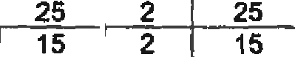
2
 | Mdanteane | 29 | 2 | 27 | 2 } | 27 | 2 | 27 | 2 | 29
Free State | Mangaung  Seloeeshe | 59  32 | 5  2 | 57  34 | 0 1 | 56  32 | 5  0 “ | 5d  32 | 5  0 " | 61  32

(4 unite) | Wdltom | 4s | 0 | 45 | 0 | ( | 37 | 0 | 37 | 0 | 37
 | Phuthadlt]haba 28 |  | 0 | 24 | 0 | ( | 23 | 0 | 23 | 0 | 23
 | Benonl | 70 | 7 | 79 | 8 |  | 74 | 6 | 74 | 6 | 80
 | Sedlbeng | 74 | 7 | 72 | 7 |  | 64 | 7 | S4 | 7 | 71
Gauteng | Pretoda  Johannesburg | 116  106 ” | 6  10 | 121  104 | 9 |  | 109  102 | 7  9 | 109  102 | 7  "9 " | 116 _  111

gouzeto 8$ 6  WestRand 60 7  Germleton 92 10  ourban 85 1  Hilton 25  Richards Bay 16 2  Polol‹wana 109 |  | 82  72  100  81  25  106 | 5 1 7s  7 51  so L »  1 1 77  2 25  6 } 109 |  | s  5  e 1  1  1  6 | 7e  51  89  70  25  15  100 | s  5  8  1  6 |  | es  50  97  77  26  18  115

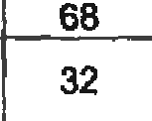(2)(a)(b}(i) The d6taile, regarding the current number of SAPS members and Public Service Act (PSA) personnel, in each lying squad unit, per provincs, In each of the specified periods, are reflected in the table balow:
Cape
Town
40
2
36
1
32
2
32
2
34
hlorth West (3 unite)
Serums Mahlken
24
26
3
22
26
18
* } 27
0 1"8
3 27
0
3
18
30

Province | F•1ylng 9quad | Cunent Pe  2010/2020  sAPS PSA |  |  | rsonnel StrenBth  2020f2021 2021/2032  SAPS P8A L SAPs PSA |  |  |  |  | Currem number of personnet, as at 13 December 2021  9APS PSA Total
 | East London | 41 |  | 0 | 52 | 0 |  | 51 | 0 | 51 |  | 0 | 51
 | Uthatha | 33 |  | 1 | 33 | 1 |  | 33 | 1 | 33 |  | 1 | 34
Eastern | Dueenstown | 26 |  | 1 | 26 | 1 |  | 28 | 1 | 28 |  | 1 | 26
‹e •nIts› |  |  | _ |  | 71 | 3 | _ | 68 | 3 | 68 | _ | 3 | 71

KwaZuju-
Natal
L3un+»1
Llmpopo
(2 unl> L | Jaliweierong  Middelburg  Ella River _ |  | 30  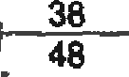 | 4  4 | 30  37  49 | 4 | 130  41  49 |  | 4  1  4 | 30  41  49 | 4  1  4 | 34  42  53

 | Rustenburg | 27 |  | 27 | 4 | [ | 24 | 4 | 2t | 4 | 2g
 | Potchefstr0gm | 1g | 2 | 18 | 2 | L | 2s | 2 | 2g | 2 | 2g
dortham  t1 un}\j | Kimberley |  |  | 42 | 2 |  | 39 | 2 | 39 | 2 | 41
Western  Cape |  | 176 | 7 | 178 | 7 |  | 177 | 7 | 177 | 7 | 184

(2)(a)(b)(ii) The details, regarding the optimal and/or ideal number of SAPS members and Public Service Act (PSA) personnel, as per the SAPS Fixed Establishment (FE), in each flying squad unit, per province, in each of the specified periods, are reflected in the table below:
Op9malfldesl Personnel Strength as pur the $APS FE
Mangaung
81
Fme State
Phuthadlt]haba 36
,Benoni 82
7
0
5
3
8
81 7
23 0
62 " 5
58 3
82 8
8J 7
23 0
62 " 5
30 3
82 8
81
23 0
62 " 5
38 3
82 _8
23
67
36
90
Gauteng
Nets!
Llmpopo

Mpumalanga
North West

Northern Cape Western caPe
 |  | (li) | (11) | (Ilj | Totnl, as per the
Province | Flying Squad | 2019f2020 | 2020/2021 | 2021C022 | current FE

8edlbeng "“ 80 | ” |  | 9 | 60"" | 9 | 60 | 9 | 80 | 8 | 69
r a _ 133 |  |  | 10 | 133 | 10 | 133 | 10 | 133 | 10 | 143

 |  | SAPS | PSA | 4AP9 | PSA | SAPS | PCA | SAPG | PSA | Total
 | East London | 40 | 3 | 40 | 3 | 40 | 3 | 40 | 3 | 43
 | Mthatha | 28 | 2 | 28 | 2 | 28 | 2 | 28 | 2 | 30
gyyj yy | Queenelown |  |  |  | -
Cape | Port Elizabeth | d0 | 4 | 80 | 4 | 60 | 4 | 80 | 4 | 64
 | King Wiltiamc  Town | 27 | 3 | 27 | 3 | 27 | 3 | 27 | 3 | 30
_ | Mdanteane _ | 15 | 2 | 15 | 2 | 15 _ | 2 | 15 | _ 2 | 17

Jahannaabure | 114 | ““10 |  |  | 1J4 | " 10 | 14“ |  | 0 | 114 |  | 10 | t24
Soweto | 86 | 9 |  |  | 86 | 9 | 86 |  | 9 | 88 |  | 9 | 95
WestRand | 58 | 8 |  |  | 58 | 8 | 58 |  | 8 | 58 |  | 8 | 66
Garmiaton | 116 | 10 |  |  | 116 | 10 | 116 |  | 10 | 116 |  | 10 | t26
Durban | 85 | 6 |  |  | 85 | 6 | 85 |  | 6 | 85 |  | 6 | 61
Hilton | 11 | 2 |  |  | f1 | 2 | 11 |  | 2 | 11 |  | 2 | 13
RlchardeBay | 12 | 2 |  |  | 12 | 2 | 12 |  | 2 | 12 |  | 2 | 14
Polokwane | s6 | 6 |  |  | so | s | ss |  | 6 | 56 |  | 8 | 62
Mahwetereng | 52 | 2 |  |  | 52 | 2_ | 52 |  | 2_ | 52 |  | 2 | 54 | _
Mlddetburg | 16 | 2 |  |  | 16 | 2 | 16 |  | 2 | 16 |  | 2 | 18
White Rlver | 26 | 2 |  |  | 26 | 2 | 2g |  | z | ‹t |  | z | w
Secunda |  | - |  |  |  | -
Mahlkeng | 23 | 5 |  |  | 23 | 5 | f5 |  | 1 | 15 |  | 1 | 16
Rustenbu\g | 21 | 2 |  |  | 21 | 2 | 15 |  | 1 | 15 |  | 1 | 16
Potch6f8troom | 13 |  | 2 | 13 |  | 2 |  | 14 | 1 | 14 |  |  | t5
Kimberley | 51 |  | 2 | 51 |  | 2 |  | 51 | 2 | SI | 2 |  | 53
Malaand | 125 |  | 5 | 125 |  | 5 |  | 125 | 5 | 125 | 5 |  | 130

Reply to question 2833 recommend/

GENERAL
TH AFRICAN POLICE SERVICE

Reply to question 2833 approved/ -

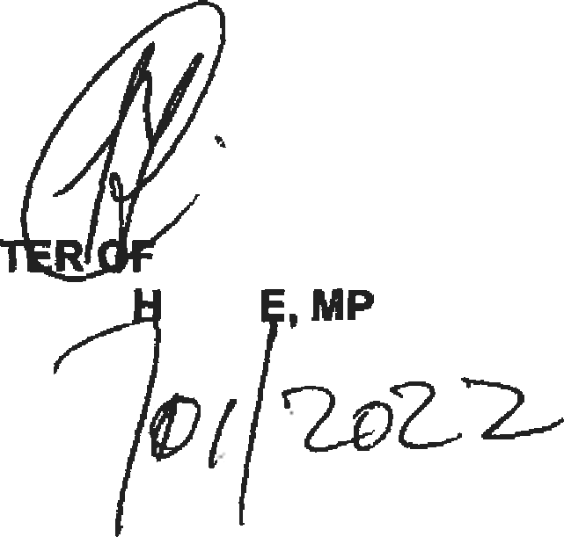
MINIS POLICE GENERAL B CEL
Date:

