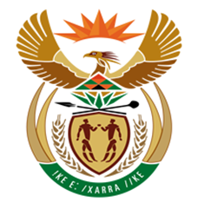

NATIONAL ASSEMBLY

QUESTION FOR WRITTEN REPLY
QUESTION NUMBER: 2830 [NW3137E]
DATE OF PUBLICATION: 15 September2017
2830. Mr J Vos (DA) to ask the Minister of Finance:
What is the total amount of value-added tax that the SA Revenue Service received from the sales of (a) domestic airline tickets and (b) international airline tickets for each airline (i) in each of the past three financial years and (ii) since 1 April 2017? NW3137E
REPLY:

The SARS systems do not differentiate the various transactions that are subject to VAT in a manner which will allow SARS to identify the VAT transactions for airline tickets separately. It should be noted further that International Airline tickets are charged VAT at 0% as they are exported services.

SARS is therefore unable to provide the data as requested.

