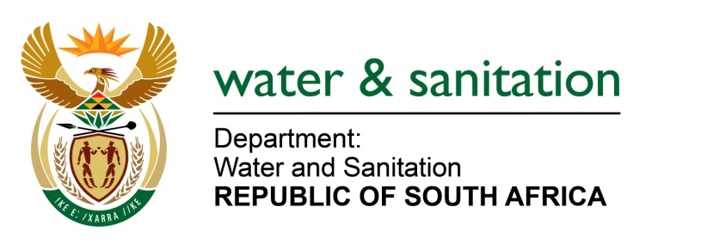

NATIONAL ASSEMBLY

FOR WRITTEN REPLY

QUESTION NO 2823

DATE OF PUBLICATION IN INTERNAL QUESTION PAPER: 7 AUGUST 2015
(INTERNAL QUESTION PAPER NO. 28)

2823. Ms T E Baker (DA) to ask the Minister of Water and Sanitation:

Whether the eThekwini Municipality took any steps to ensure that the water and sanitation infrastructure would be able to cope with increased demand before approval for (a) residential and (b) commercial developments on the KwaZulu-Natal North Coast was considered; if not, why not; if so, what are the relevant details? NW3296E
---00O00---
REPLY:
Requesting the Honourable Member to refer the question to the Minister of Corporative Governance and Traditional Affairs who is in a better position to respond to issues relating to the eThekwini Municipality.
---00O00---

