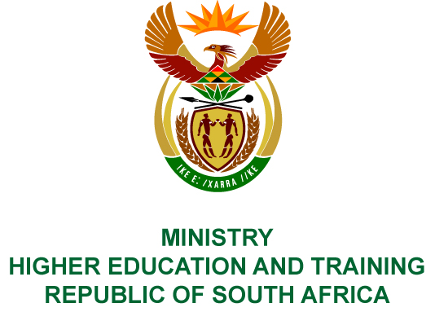
Private Bag X893, Pretoria, 0001, Tel (012) 312 5555, Fax (012) 323 5618
Private Bag X9192, Cape Town, 8000, Tel (021) 469 5150, Fax: (021) 465 7956
Memorandum from the Parliamentary Office
NATIONAL ASSEMBLY
FOR WRITTEN REPLY
QUESTION 2815
DATE OF PUBLICATION OF INTERNAL QUESTION PAPER: 14/09/2018
(INTERNAL QUESTION PAPER NO 30 OF 2018)
Mr N L S Kwankwa (UDM) to ask the Minister of Higher Education and Training:
By what date will she commit to finalise the payment of the outstanding (a) salary from April 2010 to October 2017, (b) the promised pension arrangement and (c) promised leave gratuity as undertaken by her department on 26 October 2017 to Mr Dyafta (details furnished)?
NW3108E
REPLY:
Mr Dyafta is not an employee of the Department of Higher Education and Training. Mr Dyafta was transferred to the Department of Education in the Eastern Cape after the migration process on
1 April 2015. The question should therefore be directed to the Department of Education in the Eastern Cape.

