36/1/4/1(2021)
NATIONAL ASSEMBLY

F P

2811. Mr A G Whitfield (DA) to ask the Minister of Police:

- What is the (a) nature and (b) value of the contract between the SA Police Service (SAPS) and the Government Printing Works (GPW);

- whether there have been any contractual disputes between the SAPS and the GPW in the 2019-20 financial year which have negatively affected the printing of licences; if not, what is the position in this regard; If so, what are the relevant details;

- what number of firearm llcences have been printed in each month since the
  - 2019-20 financia! year and (b) up to the latest date for which information is available†
NW3331E

REPLY:

(1)(a) The nature of the contract is the supply, printing and distribution of pńnted firearm licence and related cards.

(1)(b) The value of the contract, Wa9 R62 314 716,78. The contract was signed, on 10 November 2017 and expired, on 9 November 2020. It was extended, on 9
November 2020 to 9 May 2021 and further extended, until 9 Novembsr 2021.
Currently there Is no valid contract in place. An approval was granted for the Government Printing Works (GPW) to continue printing firearm licence cards, on a once-off quotation basis, until 30 November 2021. An application, for an additional three month extension period, has been submitted and is awaiting approval. A contract will be in place, once the internal processes, have been finalised.

(2) There have been no known contractual disputes between the South African Police Service (SAPS) and the GPW, in the 2018/2020 financial year, which negatively affected the printing of licences. The GPW is printing firearm licence cards, on behalf of the SAPS.

2

(3)(a)(b) The number of firearm licences, which were printed. in each month, since the 2019/2020 financial year, is reflected in the table below.

l¥lonth | 2019/2020 | 2020/2021 |  | 2021/Z022  (1 April 2021 to 7  December 2021]
 | 23 107 | The GPW was closed, due to COVID-19.  " 29 170 |  | 7 468
usy | 12 723 |  |  | 24 124
June  July | 13 030  14 334 "“”“ |  |  | 35 830  8 852
August | 17 616 | 12 652 |  | 26 962
September | 11 959 | 11 557 |  | 13 340
October | 13 557 | 8 826 |  | 20 246  6 403 ”
November | 13 596 | 10 187 "
 | 8 369 | 15 579 |  | 29 196
January | 13 382 _ | _ 4 464
February
March | 18 825 | 17 677
Total | 171 393 | 132 230 |  | 172 421

Reply to question 2811 recommend/be

GENERAL UTH AFRICAN POLICE SERVICE

Reply to question 2811 approved/no ged

MINISTER F POLICE
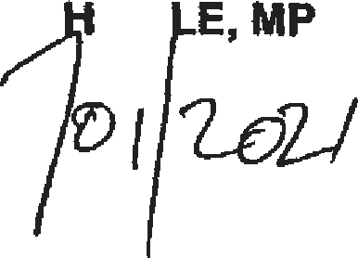
GENERAL B CE

Date: @•

