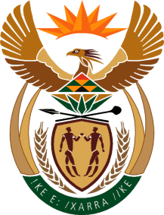

MINISTRY OF TOURISM

REPUBLIC OF SOUTH AFRICA

Private Bag X424, Pretoria, 0001, South Africa. Tel. (+27 12) 444 6780, Fax (+27 12) 444 7027

Private Bag X9154, Cape Town, 8000, South Africa. Tel. (+27 21) 469 5800, Fax: (+27 21) 465 3216

Ref: TM 2/1/1/10

NATIONAL ASSEMBLY:

QUESTION FOR WRITTEN REPLY:
Question Number: 2805
Date of Publication: 7 August 2015
NA IQP Number: 28
Date of Reply: 24 August 2015

Mr J A Esterhuizen (IFP) to ask the Minister of Tourism:
What steps is his department taking to include traditional leaders as interested parties in the domestic tourism market given that large numbers of international and domestic tourists travel to areas under the control of traditional leaders in order to further explore and admire the rich multi-cultured traditional heritage of our various communities?
NW3277E

REPLY:

The Domestic Tourism Management Branch invites Traditional Councils and Leaders to participate in the Capacity Building Seminars of the Department. These seminars are aimed at ensuring that relevant stakeholders at local level have the capacity to contribute to the growth of tourism in their communities, as well as benefiting small businesses, Non-Profit Organisations and cooperatives. Traditional leaders from most of the 27 Rural Nodes have participated.

Some of the Social Responsibility Implementation Projects have targeted areas under the jurisdiction of traditional leaders, who play a vital role in facilitating community participation and beneficiation.

